Intersection

Definition
# Source: AI Source: Provided by: [Data Path: Persons Table -> ID Column: 1, Name_En Column: Motasem Essam] -> From: [ChatGPT] on [7/25/2026]
Intersection is a geometric relationship that occurs when two or more geometric objects meet or cross at one or more common points.
The common point or set of common points is called the intersection.
For two lines $l_{1}$ and $l_{2}$, their intersection can be written as:
$$\boxed{l_{1}∩l_{2}}$$
If they meet at point $P$:
$$\boxed{l_{1}∩l_{2}=P}$$
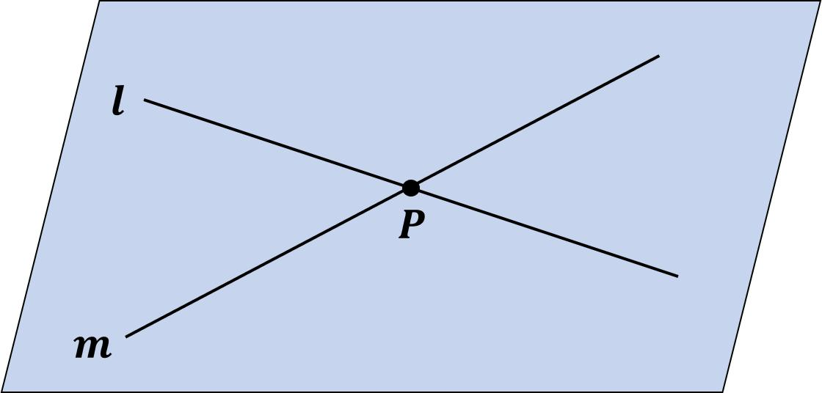
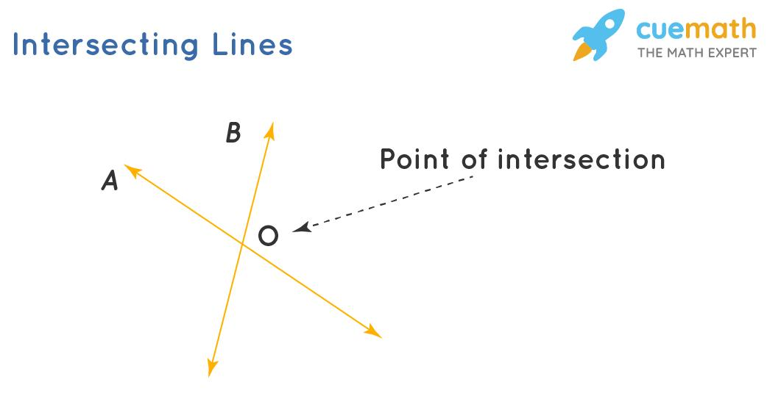
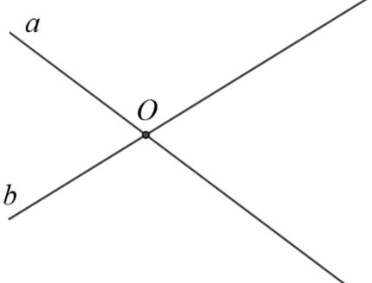
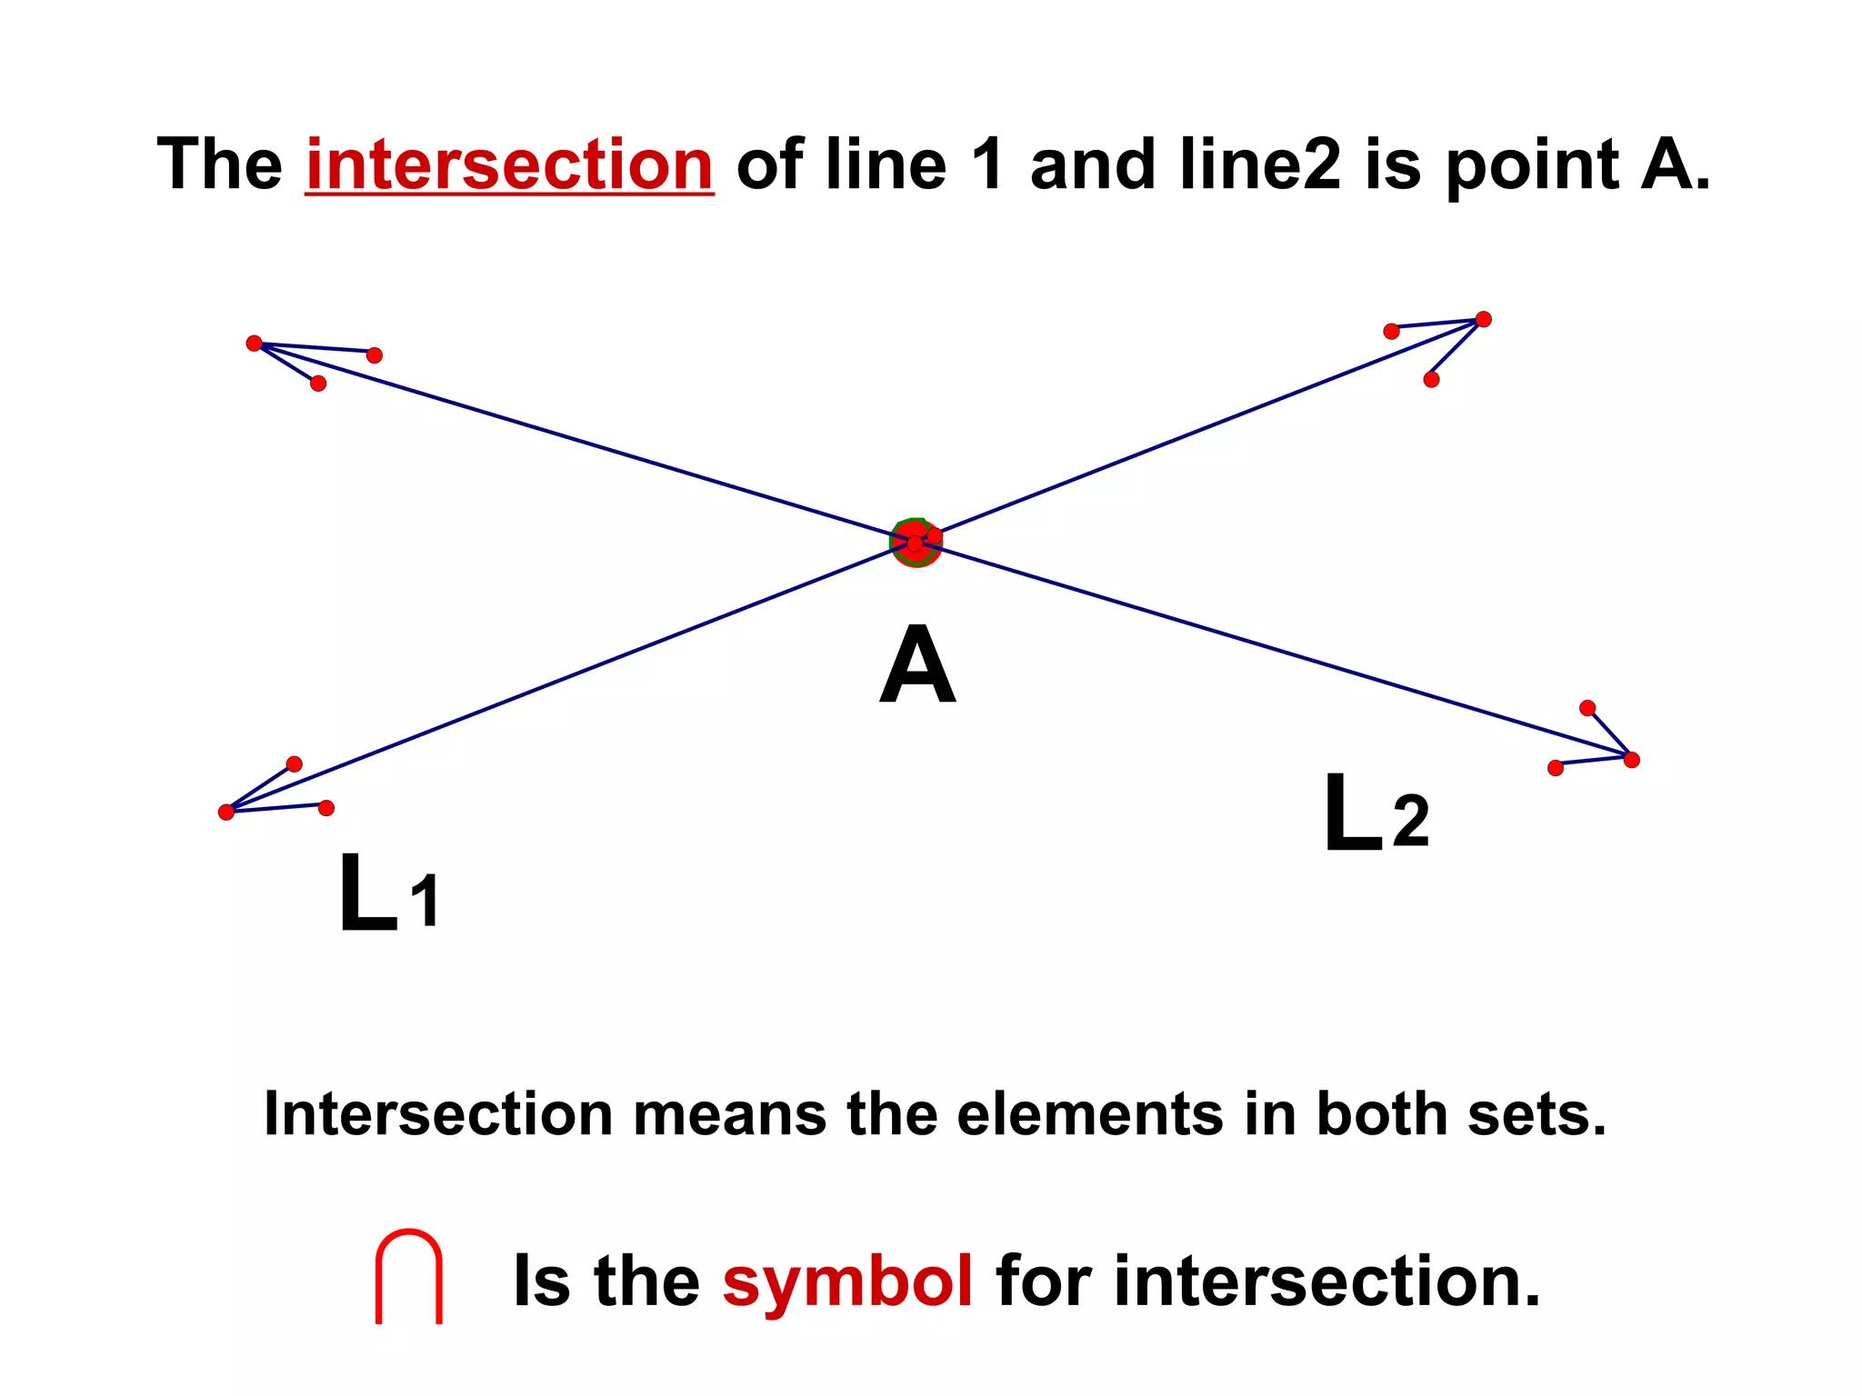
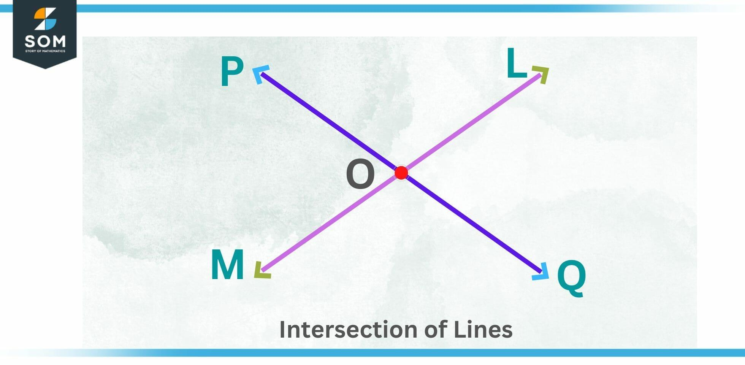

Purpose
# Source: AI Source: Provided by: [Data Path: Persons Table -> ID Column: 1, Name_En Column: Motasem Essam] -> From: [ChatGPT] on [7/25/2026]
Intersection is used to:
- Identify where geometric objects meet.
- Find common points between lines, segments, rays, and curves.
- Determine coordinates of crossing lines.
- Analyze geometric figures.
- Construct shapes and angles.
- Solve geometric and algebraic problems.
- Determine boundaries and common regions.
- Support architecture, engineering, surveying, CAD, and computer graphics.

Fundamental Idea
# Source: AI Source: Provided by: [Data Path: Persons Table -> ID Column: 1, Name_En Column: Motasem Essam] -> From: [ChatGPT] on [7/25/2026]
The fundamental idea of intersection is commonality.
If two geometric objects share a point, that point belongs to their intersection.
For example:
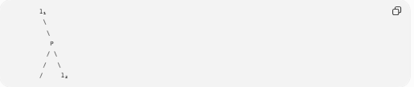
l₁
\
\
P
/ \
/ \
/ l₂
The lines intersect at:
$$▭\{\$P\$\}$$
Therefore:
$$▭\{\$l_1∩l_2=P\$\}$$
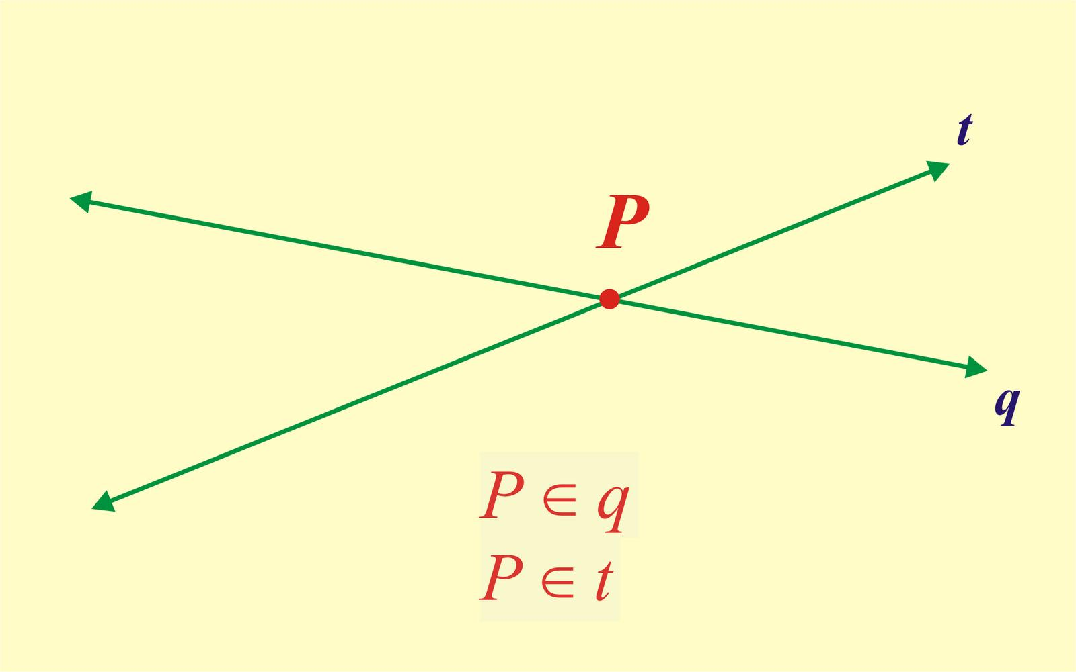
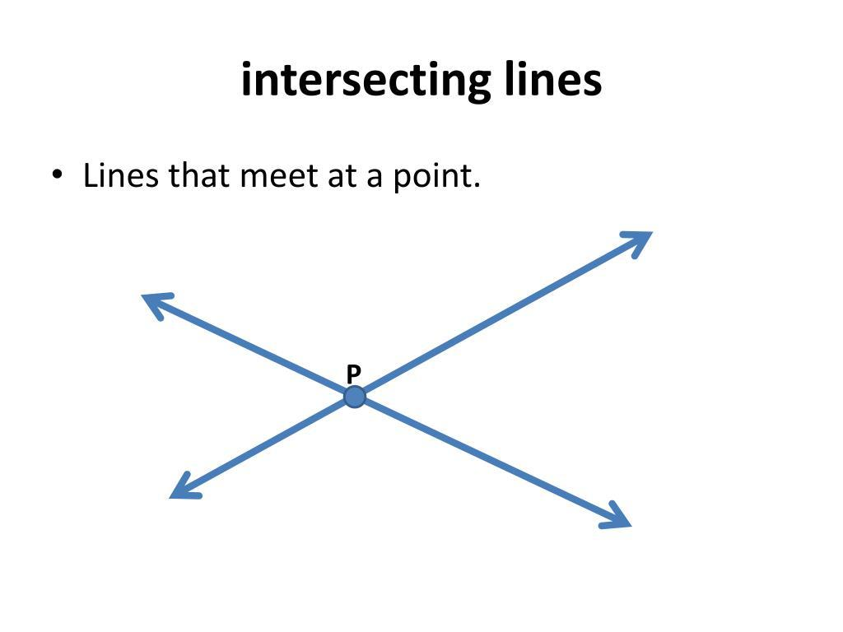
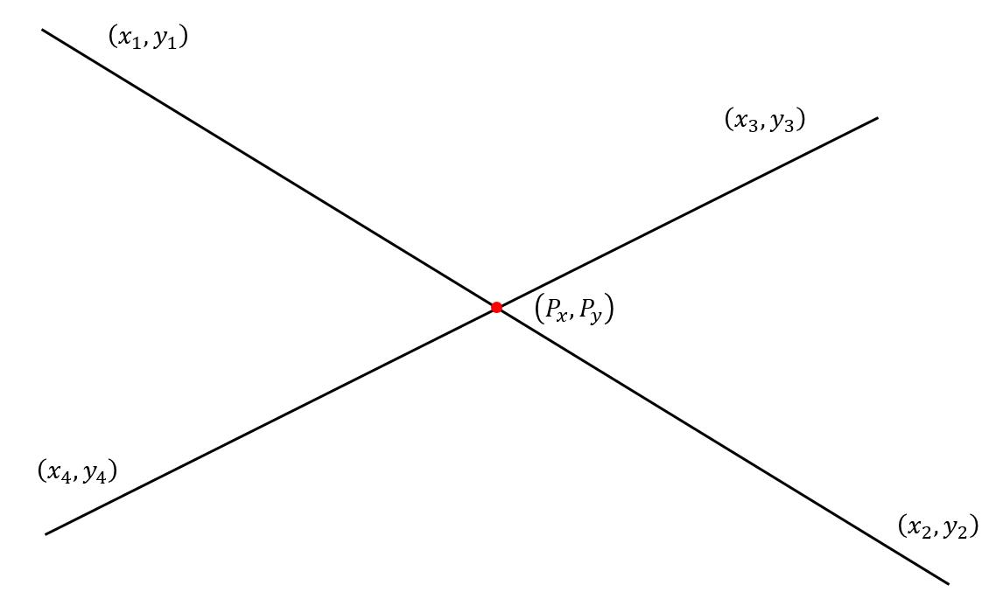
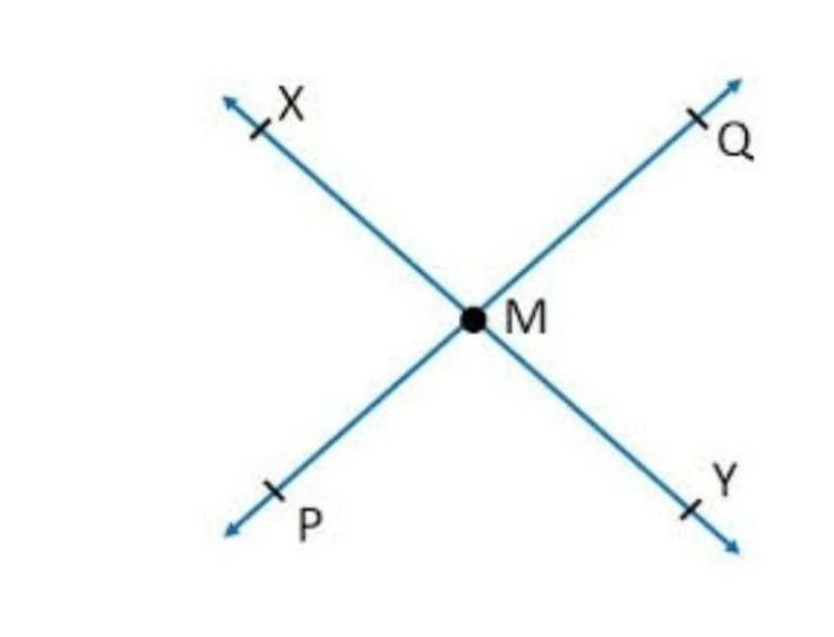
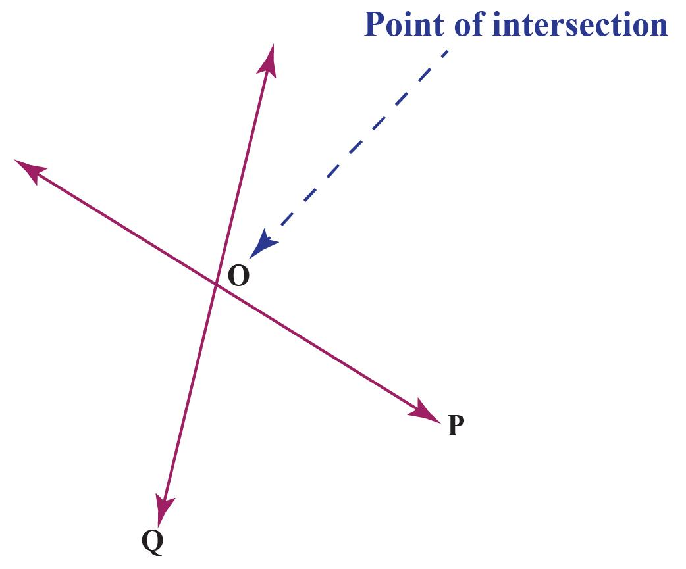

Intersection Notation
# Source: AI Source: Provided by: [Data Path: Persons Table -> ID Column: 1, Name_En Column: Motasem Essam] -> From: [ChatGPT] on [7/25/2026]
The symbol for intersection is:
$$\boxed{∩}$$
For two sets or geometric objects $A$ and $B$:
$$▭\{\$A∩B\$\}$$
means:
The points that belong to both $A$ and $B$.
For example:
$$▭\{\$l_1∩l_2=P\$\}$$
means that $l_{1}$ and $l_{2}$ intersect at $P$.

Types of Intersection
# Source: AI Source: Provided by: [Data Path: Persons Table -> ID Column: 1, Name_En Column: Motasem Essam] -> From: [ChatGPT] on [7/25/2026]
Geometric objects can have different types of intersections depending on their shapes and positions.
The main cases include:
- Point Intersection
- Multiple-Point Intersection
- Segment Intersection
- Coincident Intersection
- No Intersection

1. Point Intersection
# Source: AI Source: Provided by: [Data Path: Persons Table -> ID Column: 1, Name_En Column: Motasem Essam] -> From: [ChatGPT] on [7/25/2026]
A point intersection occurs when two geometric objects meet at exactly one point.
For example, two non-parallel lines normally intersect at one point.
$$▭\{\$l_1∩l_2=P\$\}$$
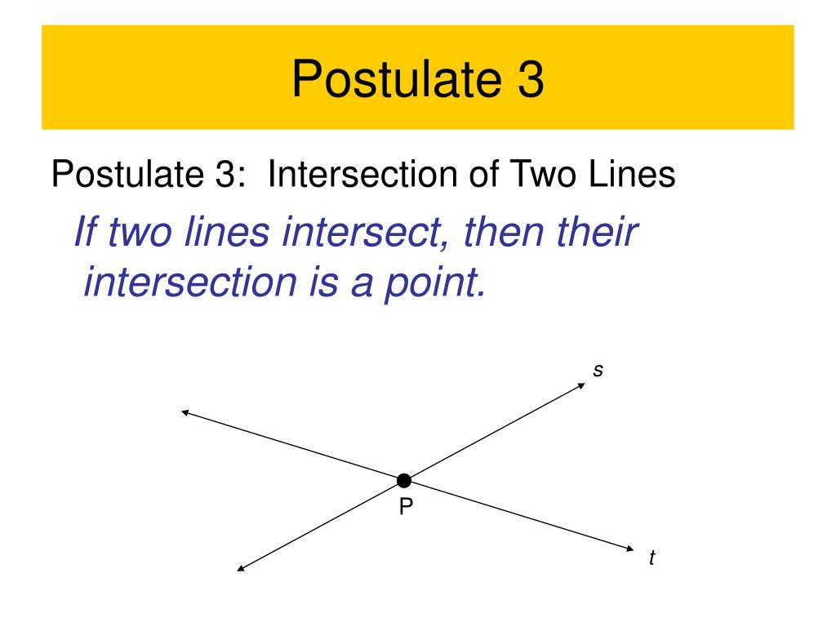
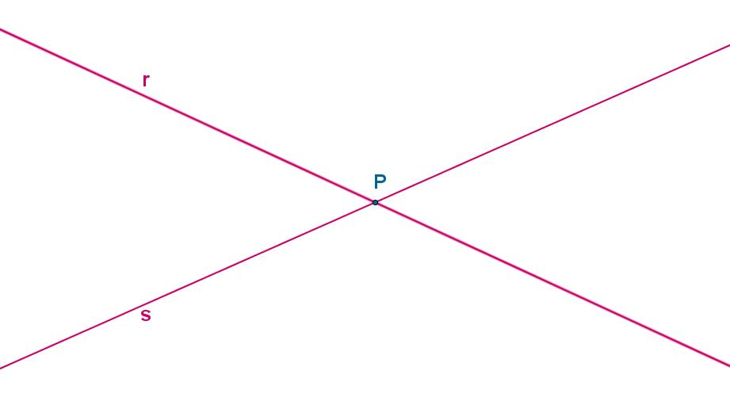
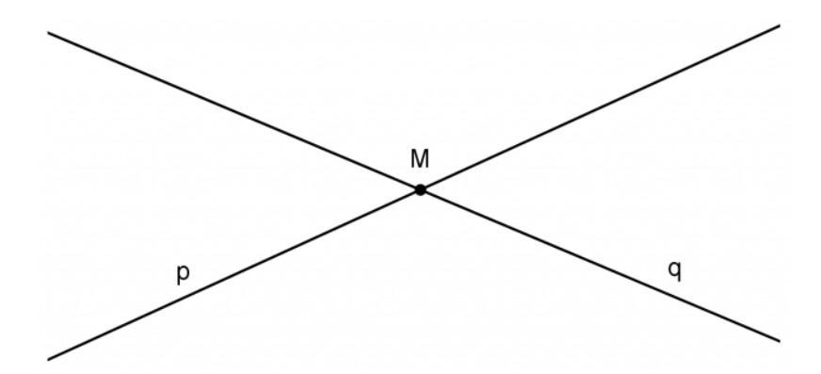
Examples include:
- Two intersecting lines.
- Two rays meeting at a common endpoint.
- Two curves crossing once.
- Two line segments crossing.

2. Multiple-Point Intersection
# Source: AI Source: Provided by: [Data Path: Persons Table -> ID Column: 1, Name_En Column: Motasem Essam] -> From: [ChatGPT] on [7/25/2026]
Some geometric objects can intersect at more than one point.
For example, a line can intersect a circle at two points.
$$▭\{\$l∩C=A,B\$\}$$
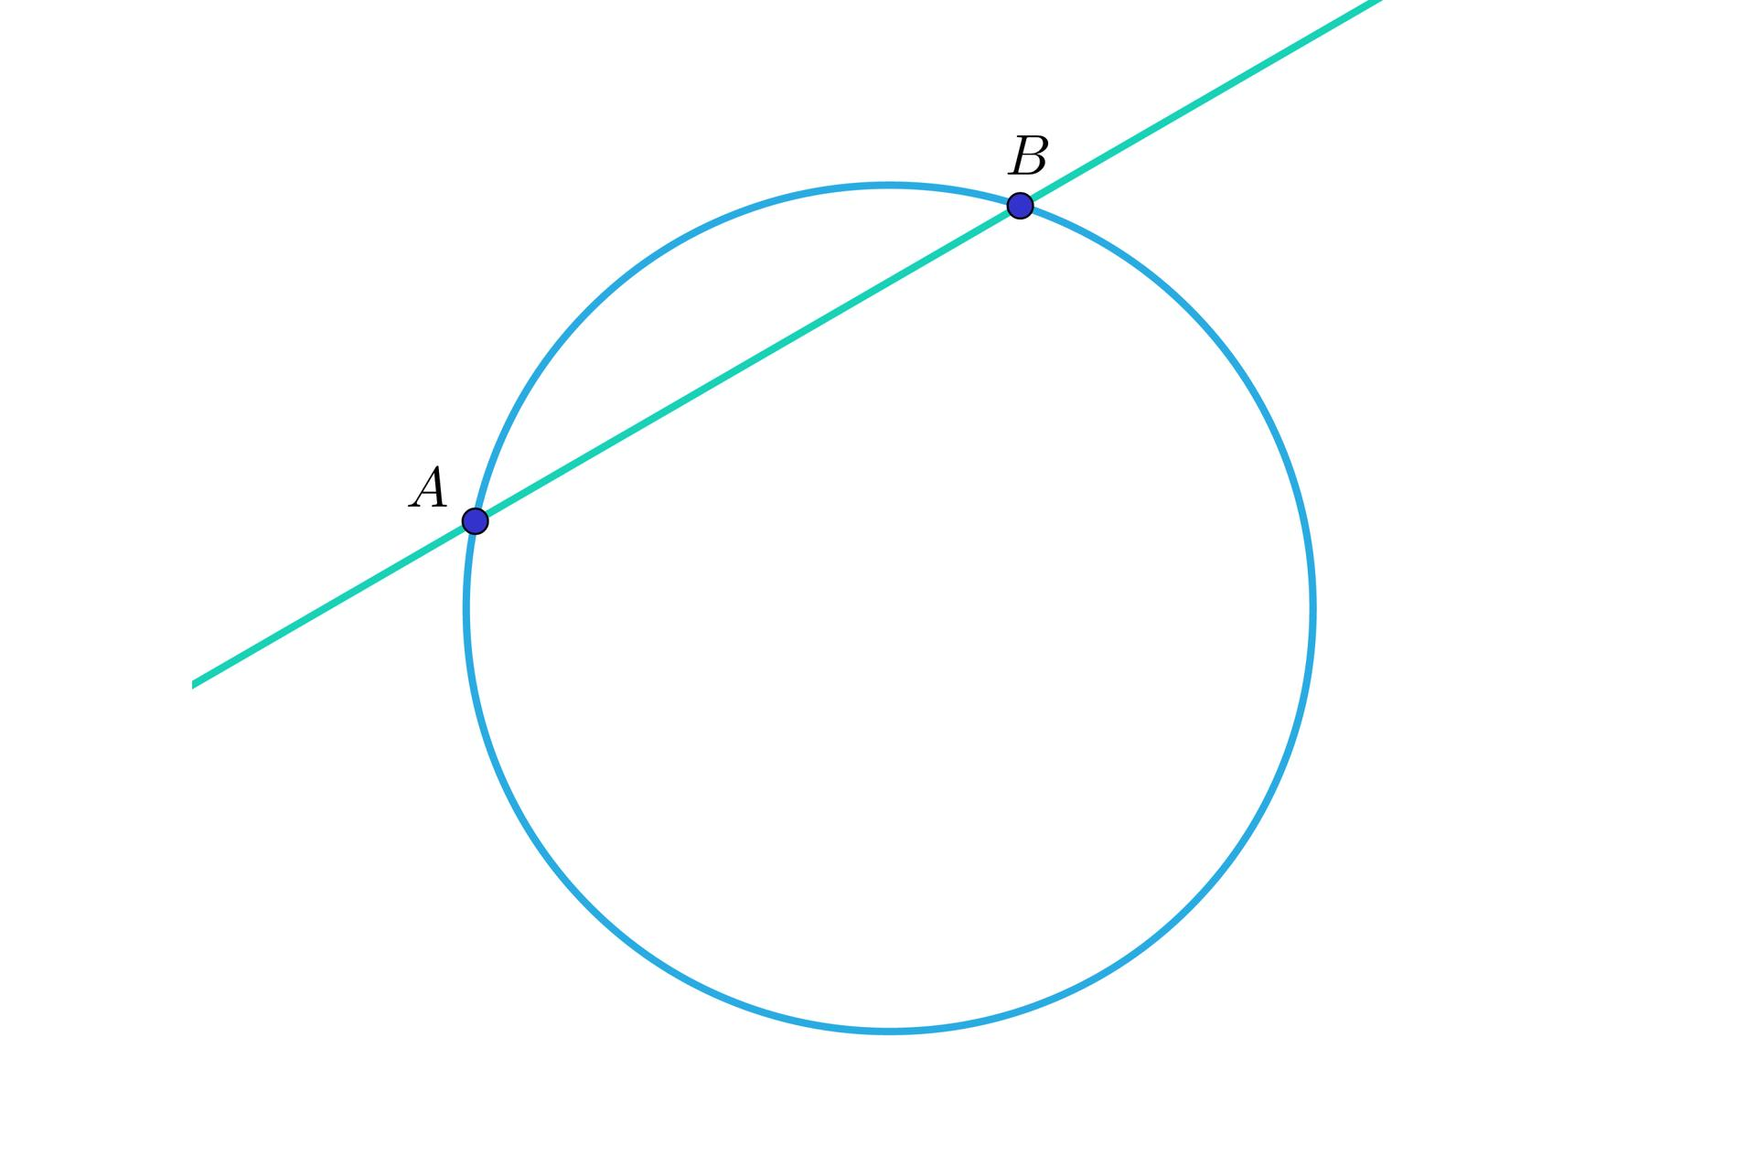
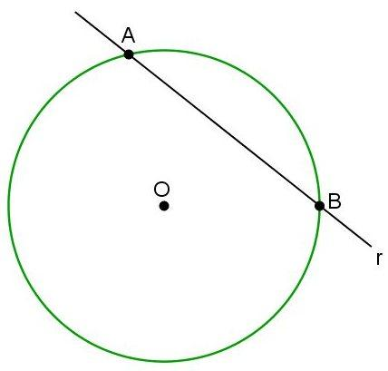
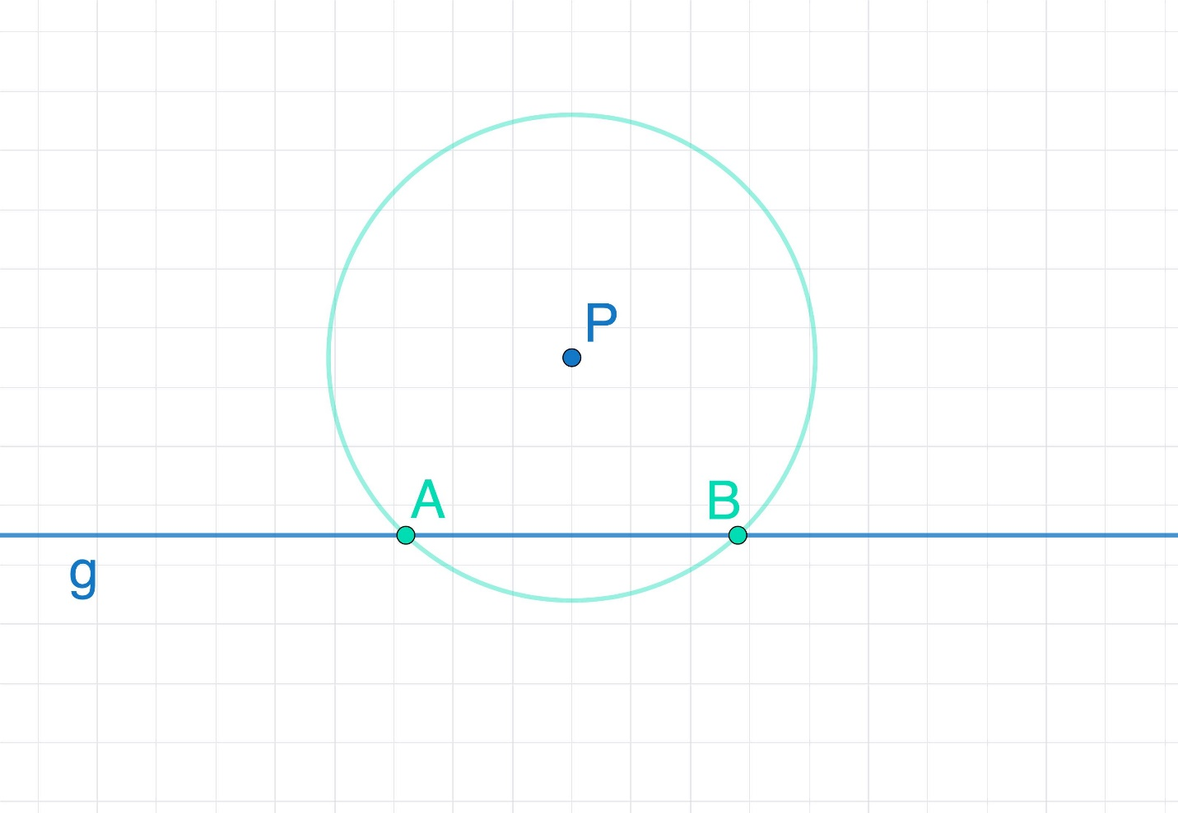
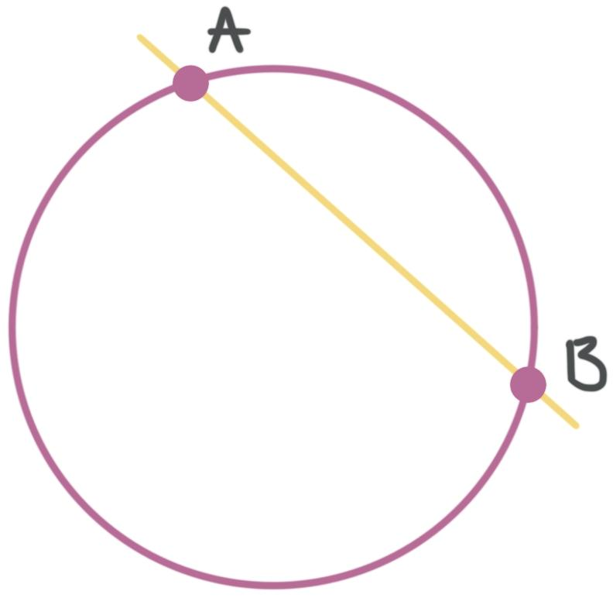
A line crossing a circle can therefore have:
$$▭\{\$0, 1, Ⅎr\{or \}2\$\}$$
intersection points.

3. Segment Intersection
# Source: AI Source: Provided by: [Data Path: Persons Table -> ID Column: 1, Name_En Column: Motasem Essam] -> From: [ChatGPT] on [7/25/2026]
Two line segments can intersect at a point.
For example:
$$\overline{AB}∩\overline{CD}=\{P\}$$
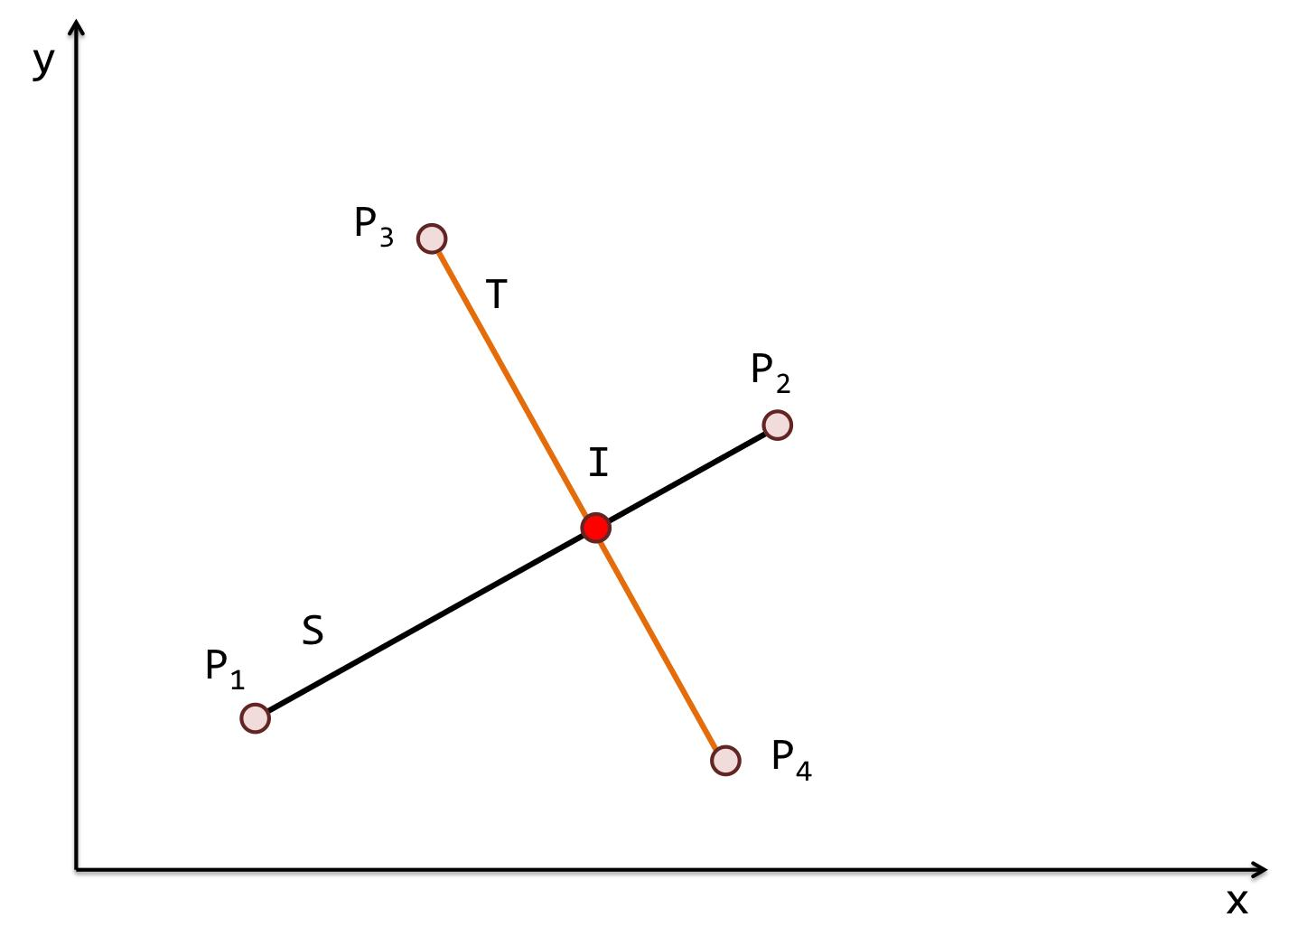
This is common in:
- Polygon diagonals.
- Geometric constructions.
- Graphs.
- CAD drawings.
- Structural designs.

4. Coincident Intersection
# Source: AI Source: Provided by: [Data Path: Persons Table -> ID Column: 1, Name_En Column: Motasem Essam] -> From: [ChatGPT] on [7/25/2026]
Two geometric objects are coincident when they occupy the same location.
For example, if two lines lie exactly on top of each other:
$$\boxed{l_{1}=l_{2}}$$
Their intersection is the entire line:
$$\boxed{l_{1}∩l_{2}=l_{1}}$$
Therefore, they have infinitely many common points.
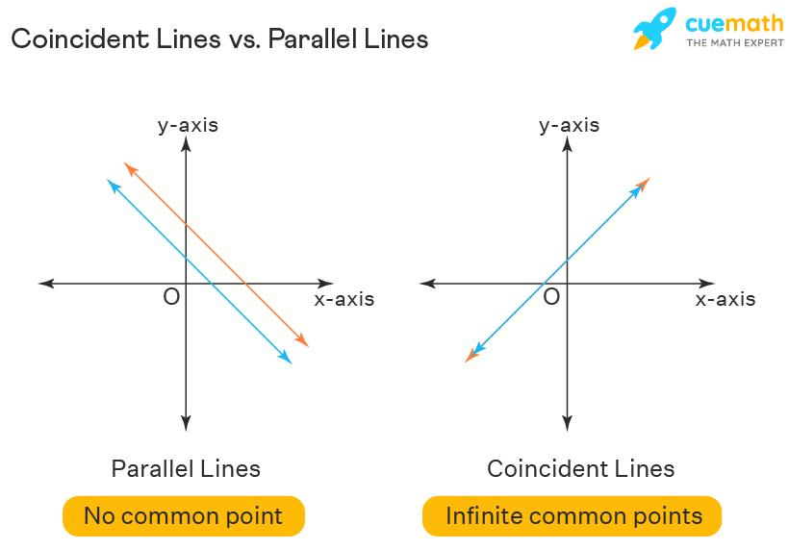
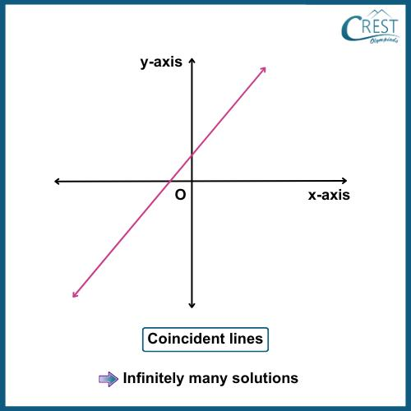
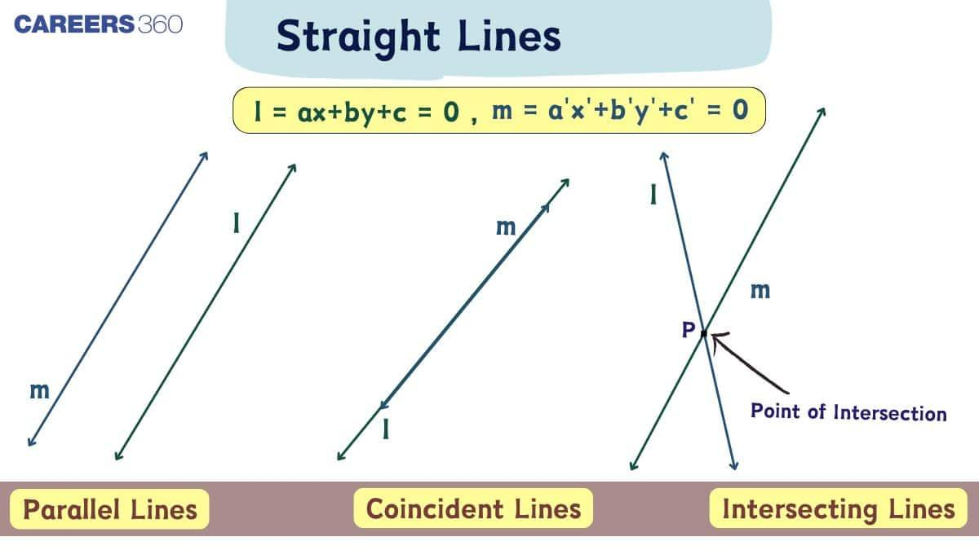

5. No Intersection
# Source: AI Source: Provided by: [Data Path: Persons Table -> ID Column: 1, Name_En Column: Motasem Essam] -> From: [ChatGPT] on [7/25/2026]
Two geometric objects may have no common points.
For example, distinct parallel lines do not intersect.
$$\boxed{l_{1}∥l_{2}}$$
Therefore:
$$\boxed{l_{1}∩l_{2}=∅}$$
where:
$$\boxed{∅}$$
means the empty set.
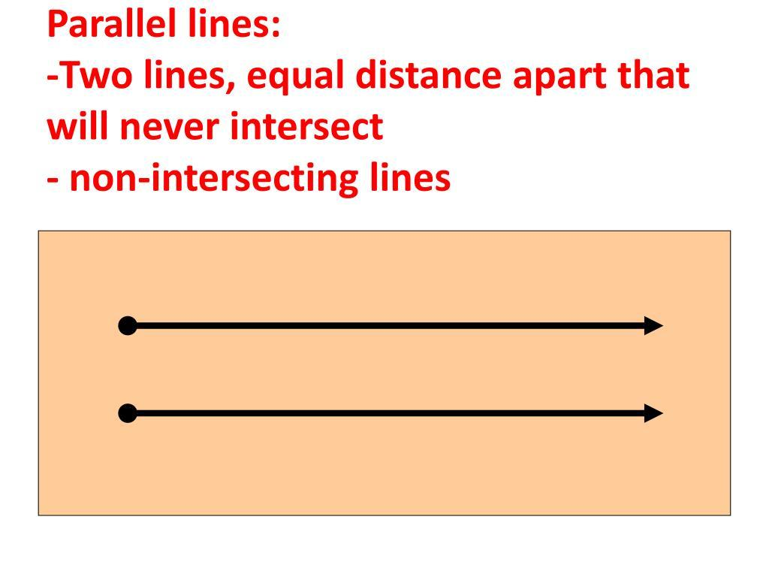
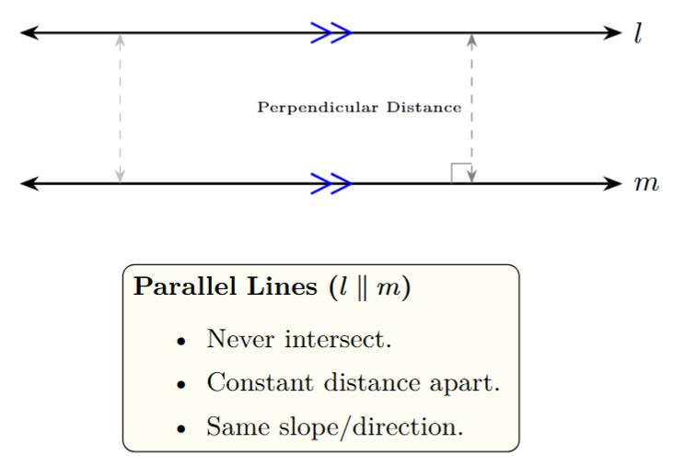
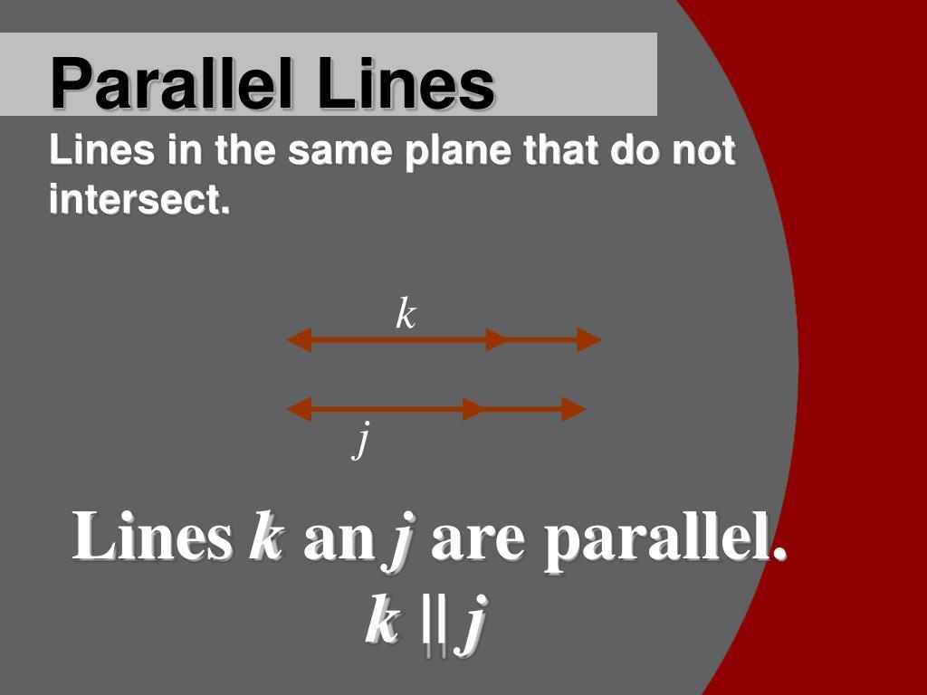
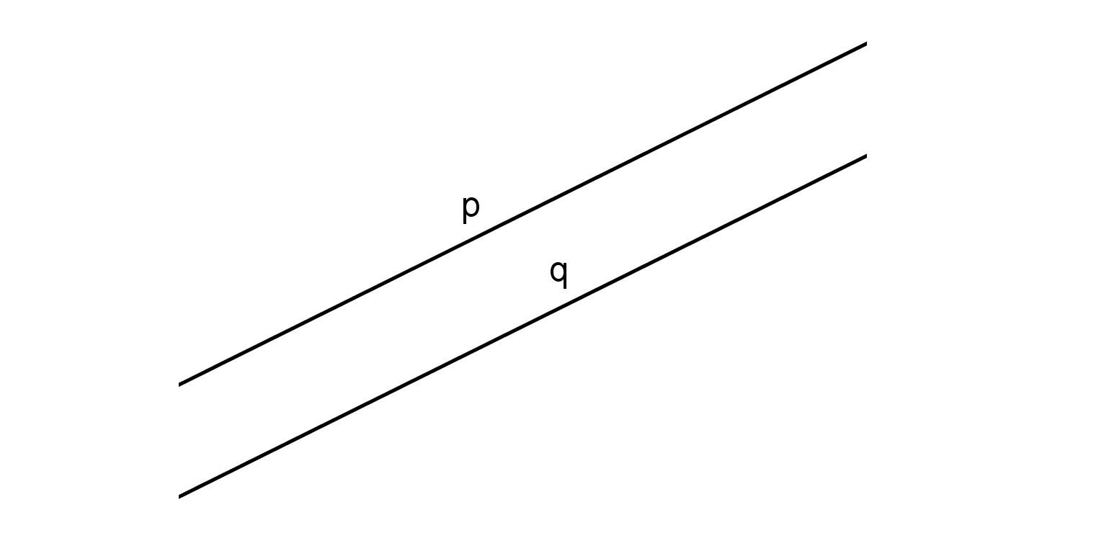

Intersection of Two Lines
# Source: AI Source: Provided by: [Data Path: Persons Table -> ID Column: 1, Name_En Column: Motasem Essam] -> From: [ChatGPT] on [7/25/2026]
Two distinct lines in a plane can have three possible relationships:
1. Intersecting
They meet at exactly one point
$$\boxed{l_{1}∩l_{2}=P}$$
2. Parallel
They never meet.
$$\boxed{l_{1}∩l_{2}=∅}$$
3. Coincident
They are the same line.
$$\boxed{l_{1}∩l_{2}=l_{1}}$$
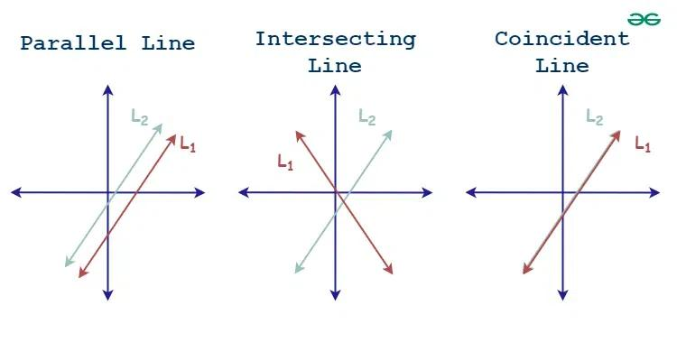
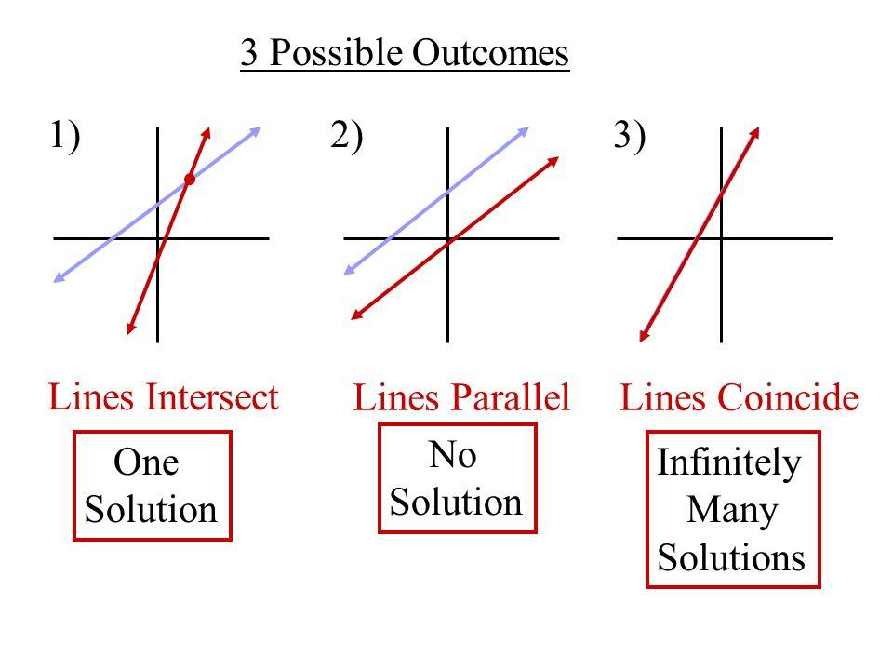
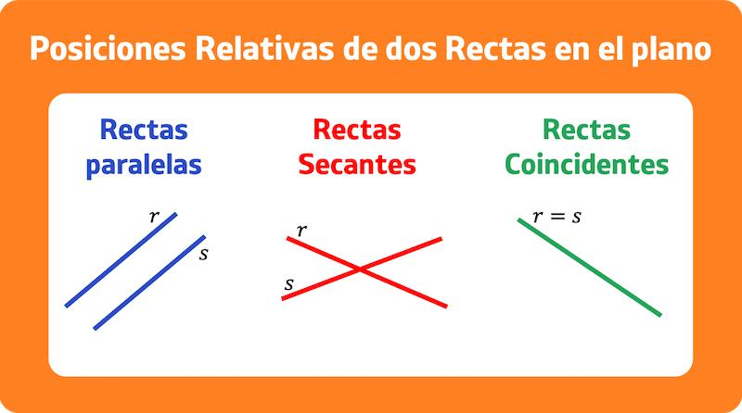

Intersection of Lines and Curves
# Source: AI Source: Provided by: [Data Path: Persons Table -> ID Column: 1, Name_En Column: Motasem Essam] -> From: [ChatGPT] on [7/25/2026]
A line can intersect a curve at different numbers of points.
For example, a line and a circle can have:
No Intersection
$$\boxed{0 \text{p}\text{oints}}$$
Tangent Intersection
$$\boxed{1 \text{p}\text{oint}}$$
Secant Intersection
$\boxed{2 \text{p}\text{oints}}$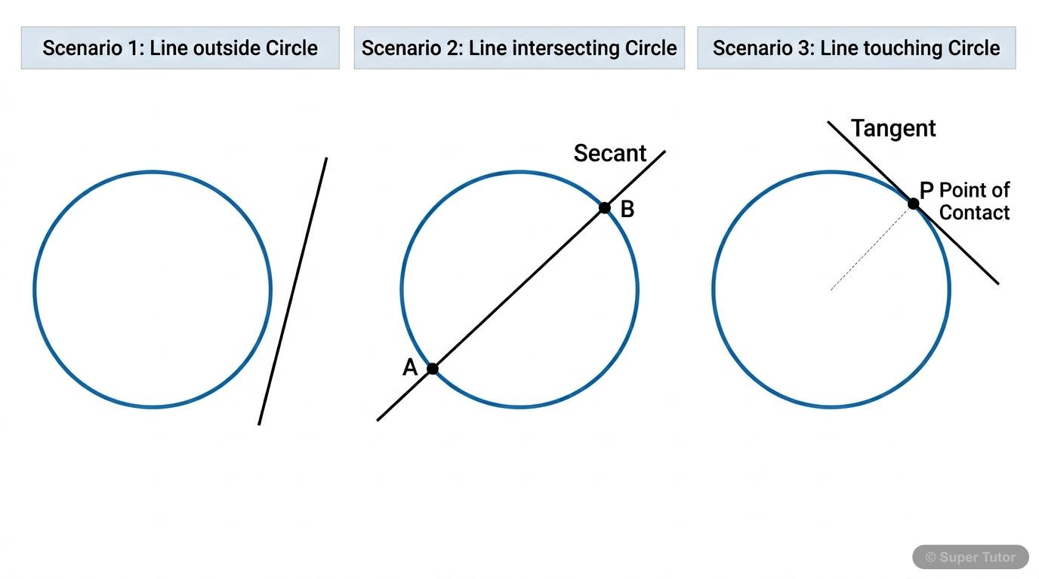
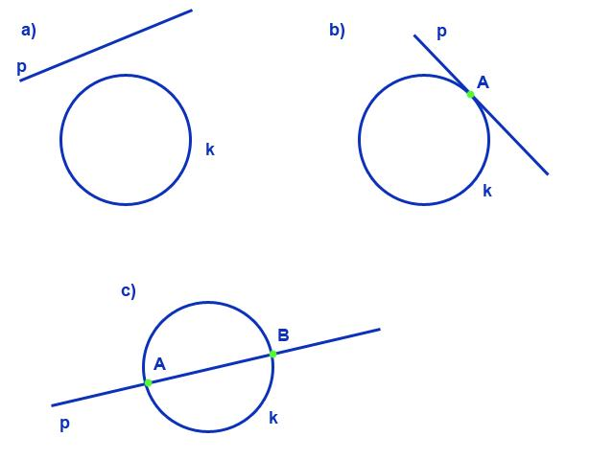
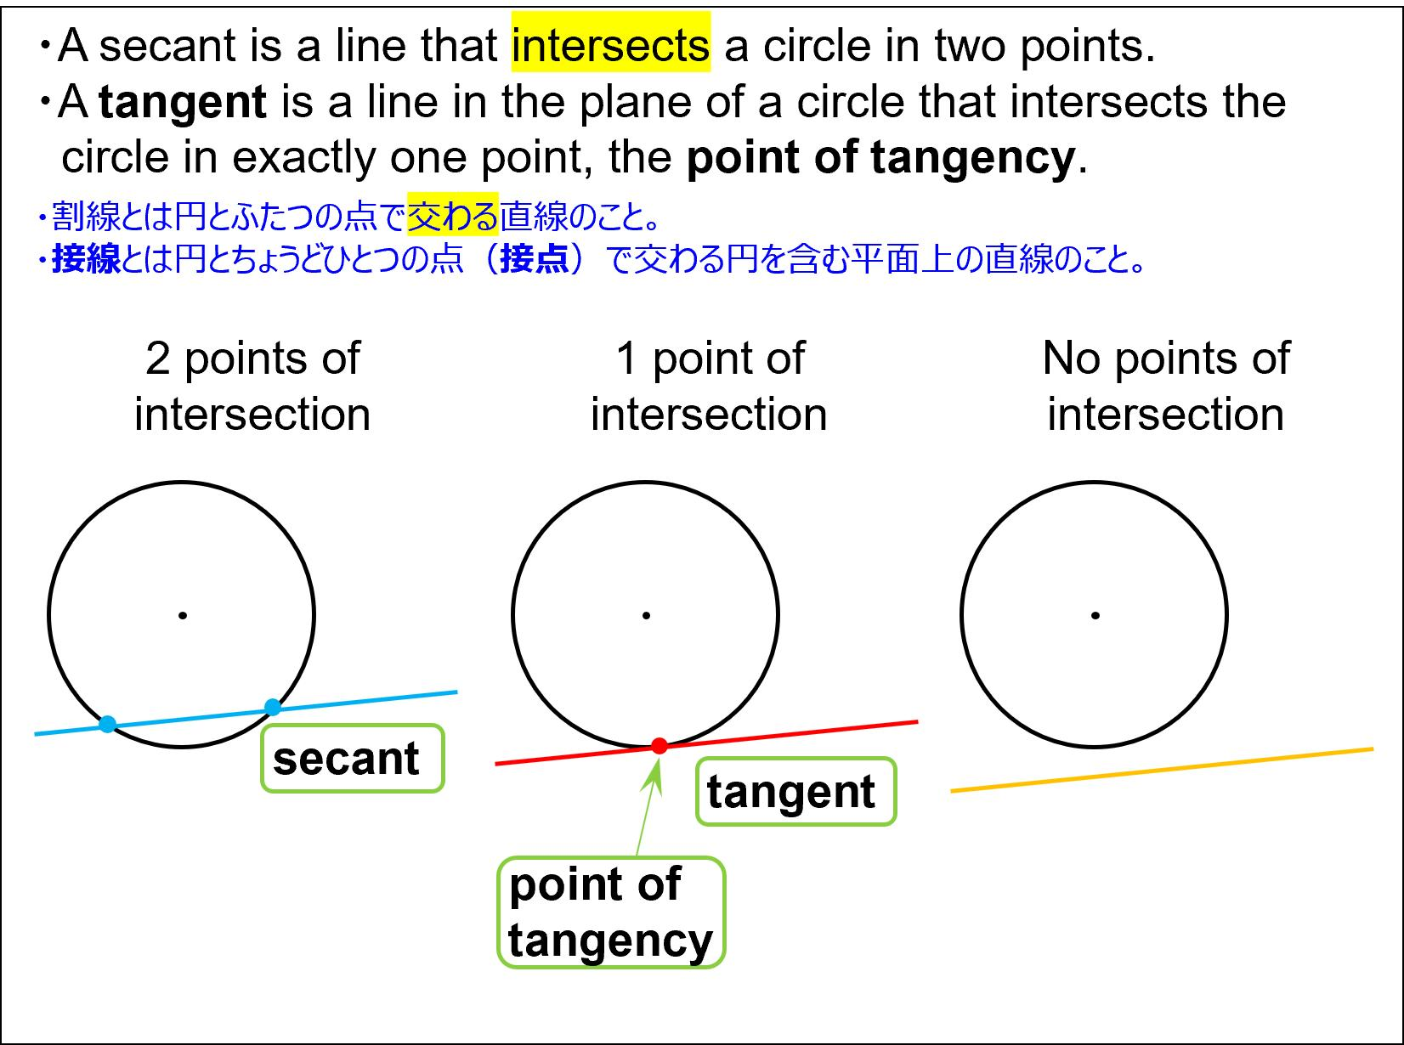

Tangent Intersection
# Source: AI Source: Provided by: [Data Path: Persons Table -> ID Column: 1, Name_En Column: Motasem Essam] -> From: [ChatGPT] on [7/25/2026]
A tangent line touches a circle at exactly one point.
That point is called the point of tangency.
If line $l$ touches circle $C$ at $P$:
$$\boxed{l∩C=P}$$
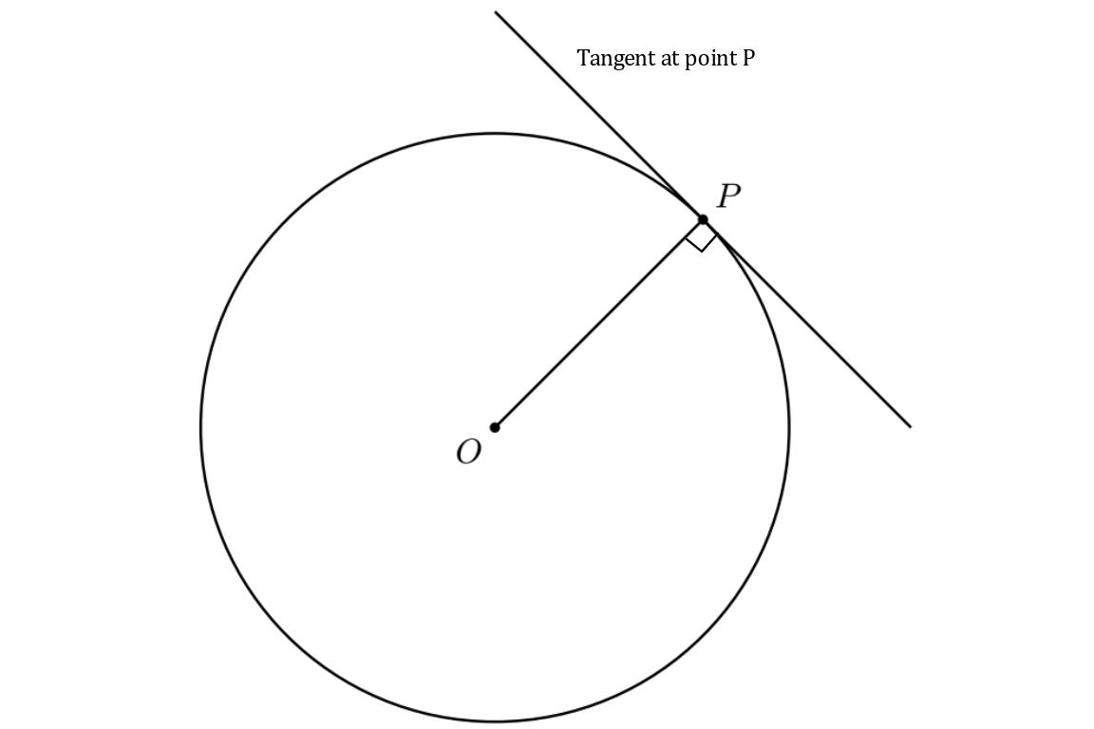
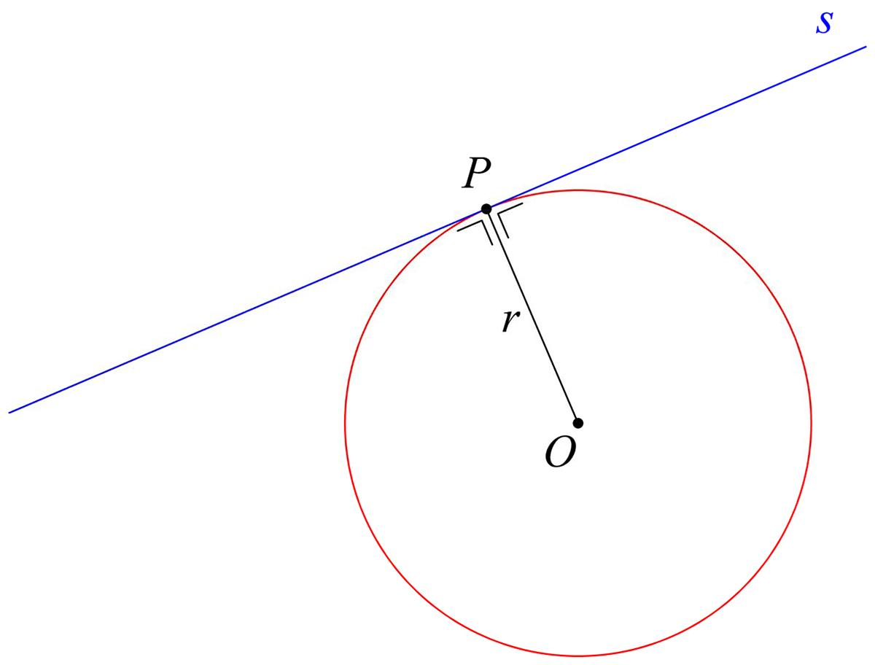
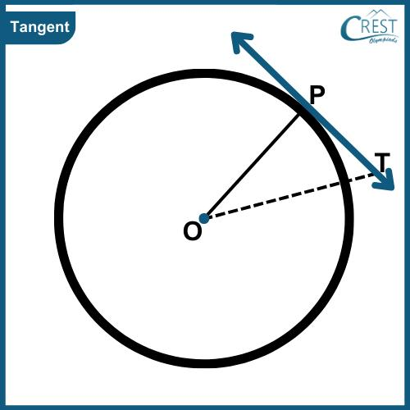
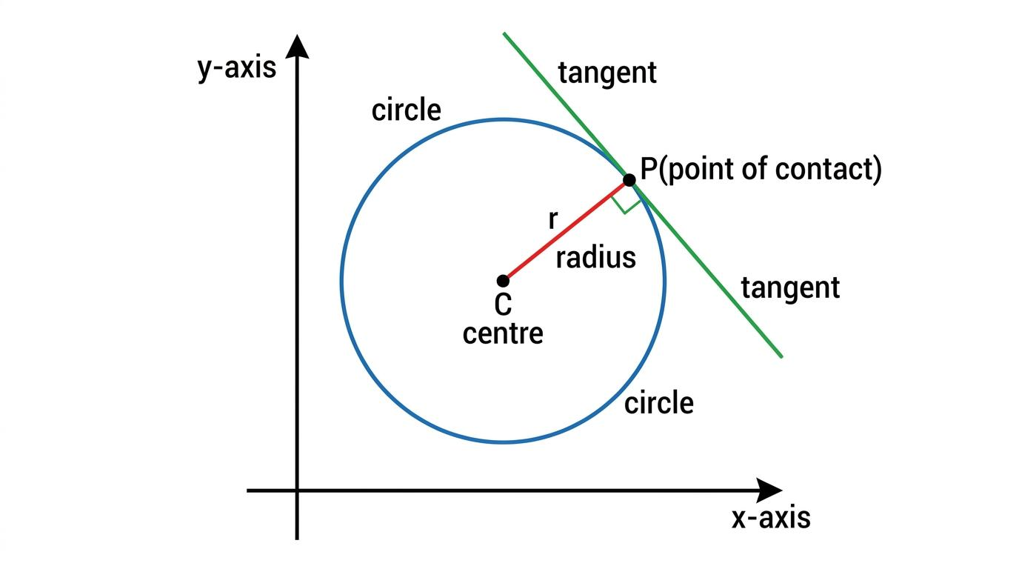
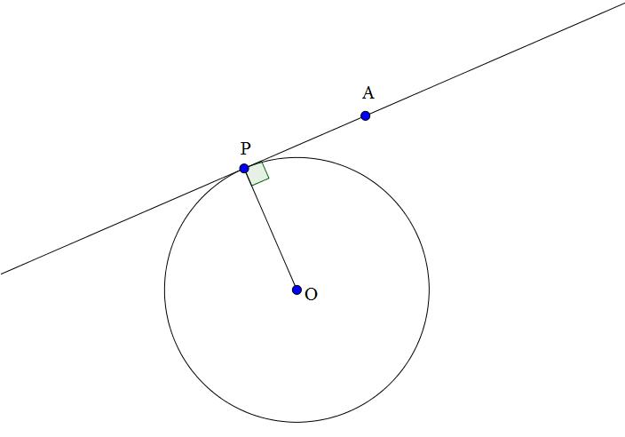

Secant Intersection
# Source: AI Source: Provided by: [Data Path: Persons Table -> ID Column: 1, Name_En Column: Motasem Essam] -> From: [ChatGPT] on [7/25/2026]
A secant line intersects a circle at two distinct points.
If the intersection points are $A$ and $B$:
$$\boxed{l∩C=A,B}$$
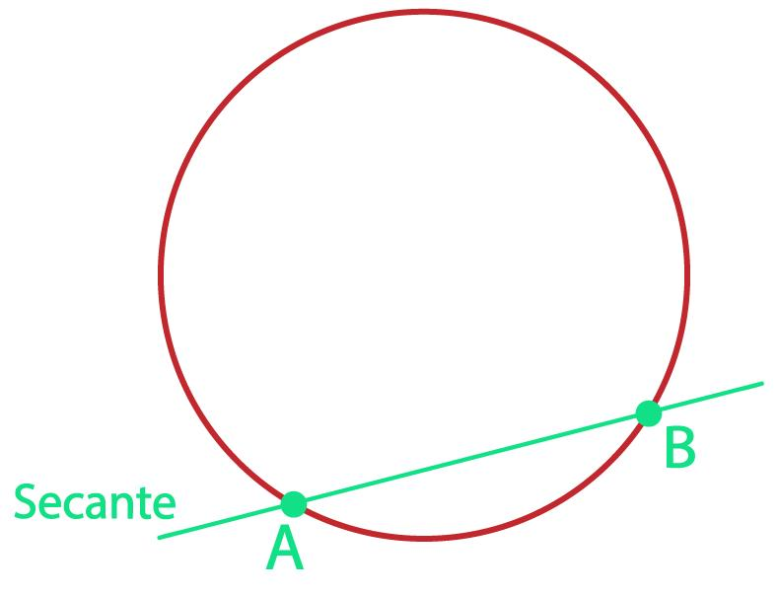
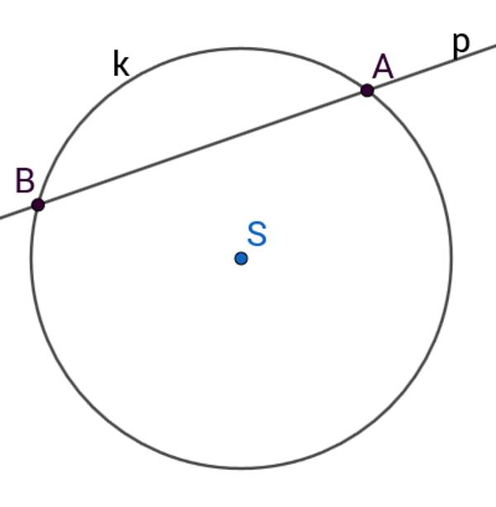
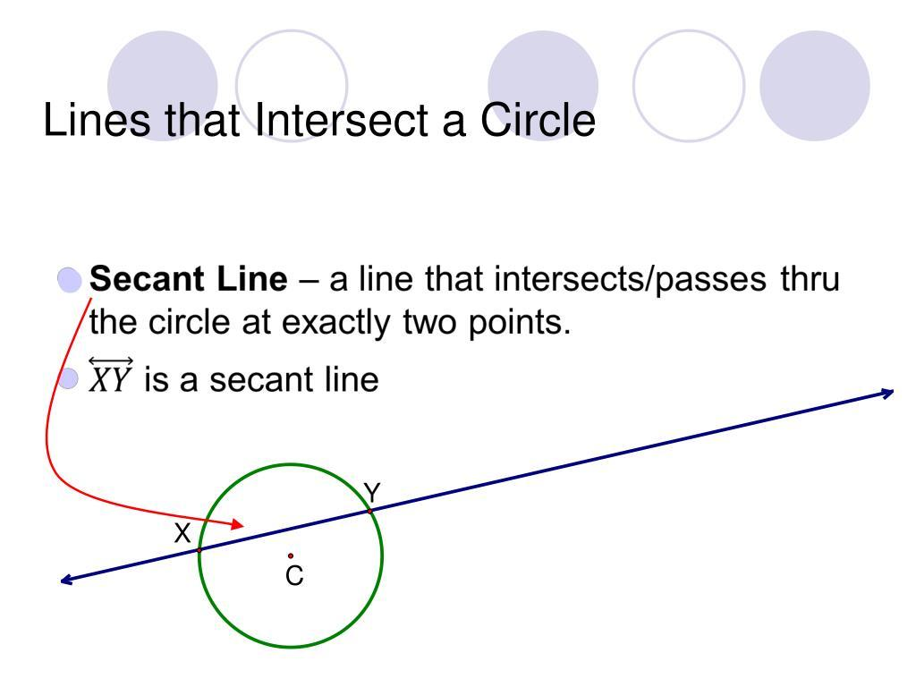

Intersection of Rays
# Source: AI Source: Provided by: [Data Path: Persons Table -> ID Column: 1, Name_En Column: Motasem Essam] -> From: [ChatGPT] on [7/25/2026]
Two rays can intersect at their common endpoint or at another point.
For example:
$$\vec{AB}$$
and:
$$\vec{CD}$$
may intersect at $P$.
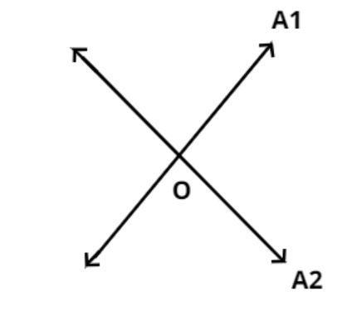
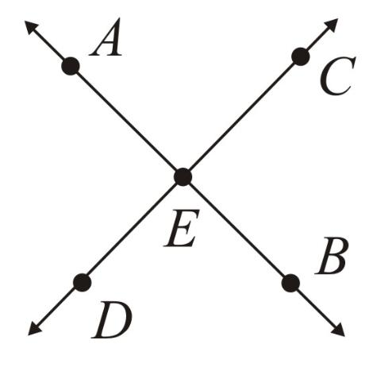
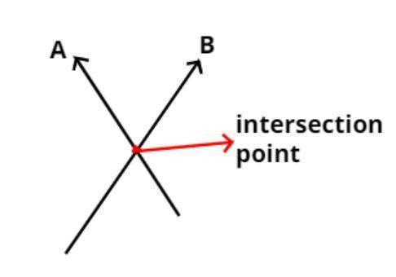
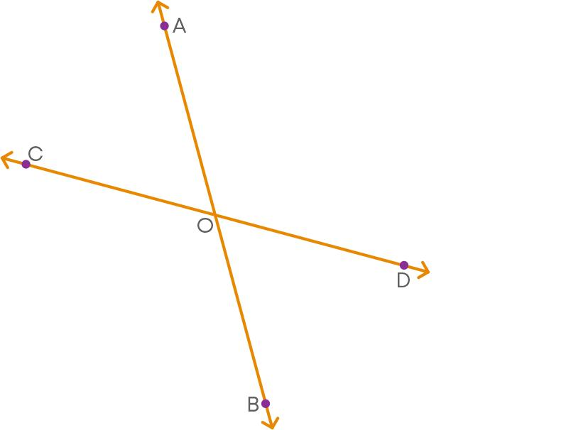

Intersection of Two Circles
# Source: AI Source: Provided by: [Data Path: Persons Table -> ID Column: 1, Name_En Column: Motasem Essam] -> From: [ChatGPT] on [7/25/2026]
Two circles can have different intersection relationships.
No Intersection
The circles do not meet.
One Intersection
The circles are tangent.
Two Intersections
The circles cross at two points.
Coincident Circles
The circles have exactly the same center and radius.
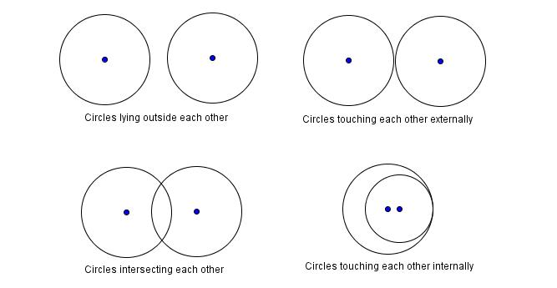
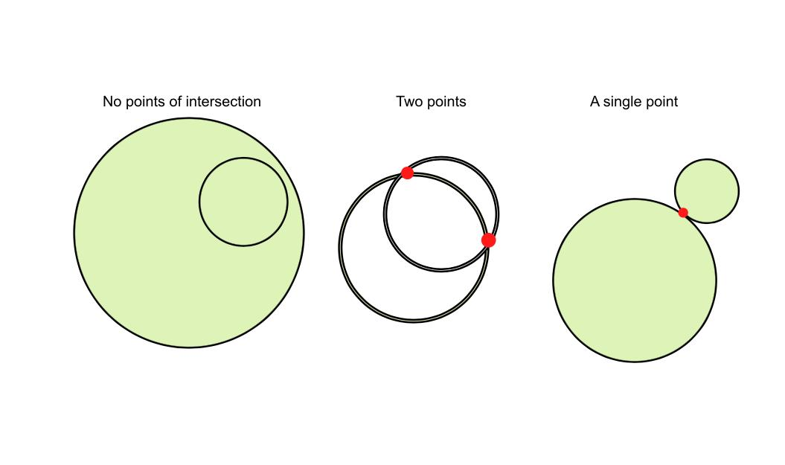
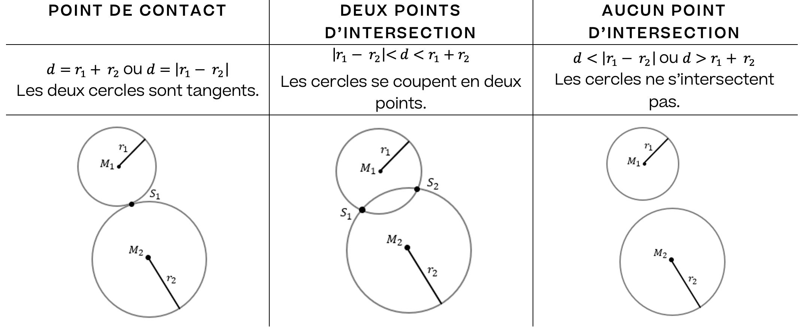

Intersection in Polygons
# Source: AI Source: Provided by: [Data Path: Persons Table -> ID Column: 1, Name_En Column: Motasem Essam] -> From: [ChatGPT] on [7/25/2026]
Intersections occur naturally within polygons.
For example, the diagonals of a quadrilateral may intersect at a point.
For a rectangle:
$$\boxed{AC∩BD=O}$$
where $O$ is the intersection of the diagonals.
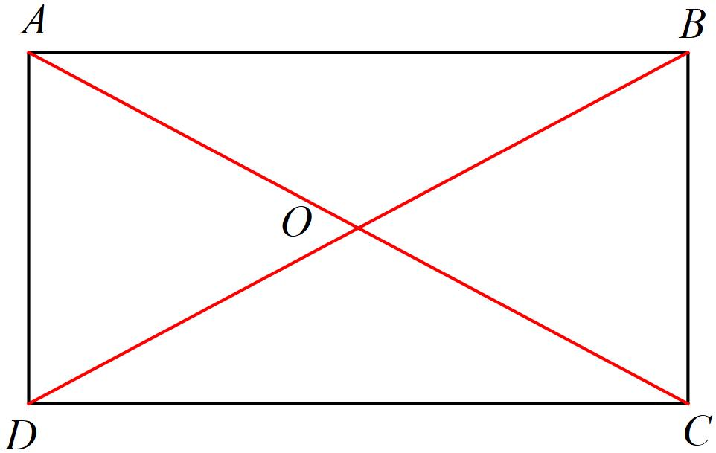
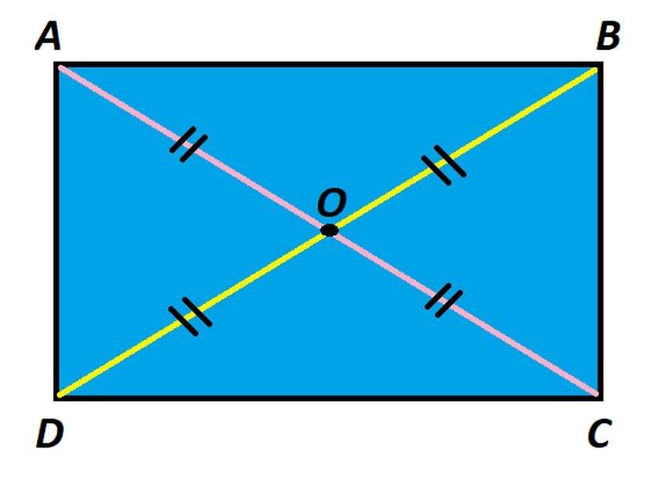
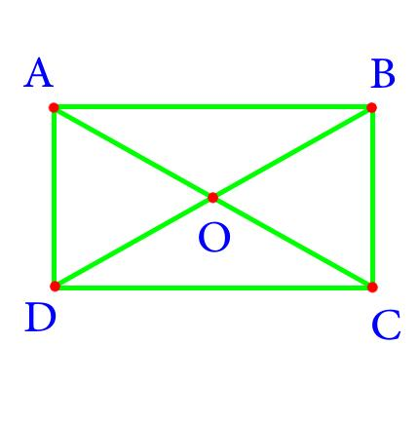
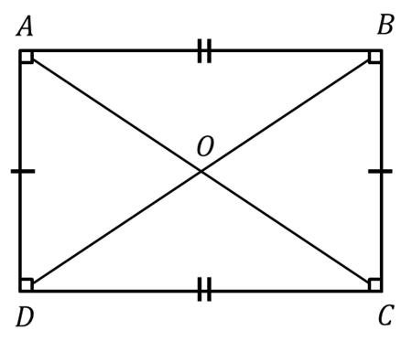
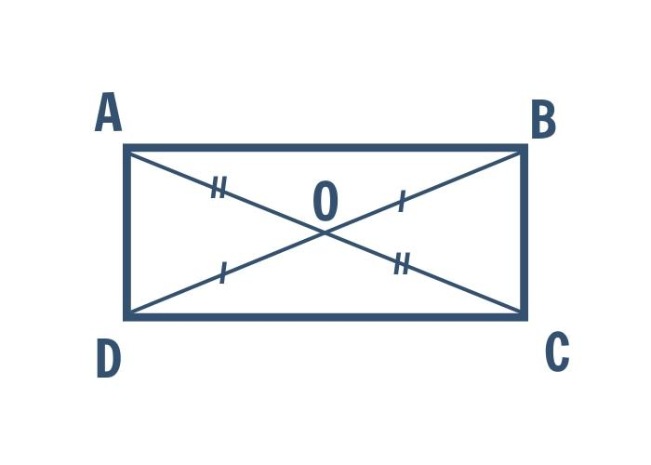

Intersection of Diagonals
# Source: AI Source: Provided by: [Data Path: Persons Table -> ID Column: 1, Name_En Column: Motasem Essam] -> From: [ChatGPT] on [7/25/2026]
The diagonals of many polygons intersect inside the figure.
For example, a square has two diagonals:
$$\overline{AC}$$
and:
$$\overline{BD}$$
Their intersection is:
$$\boxed{AC∩BD=O}$$
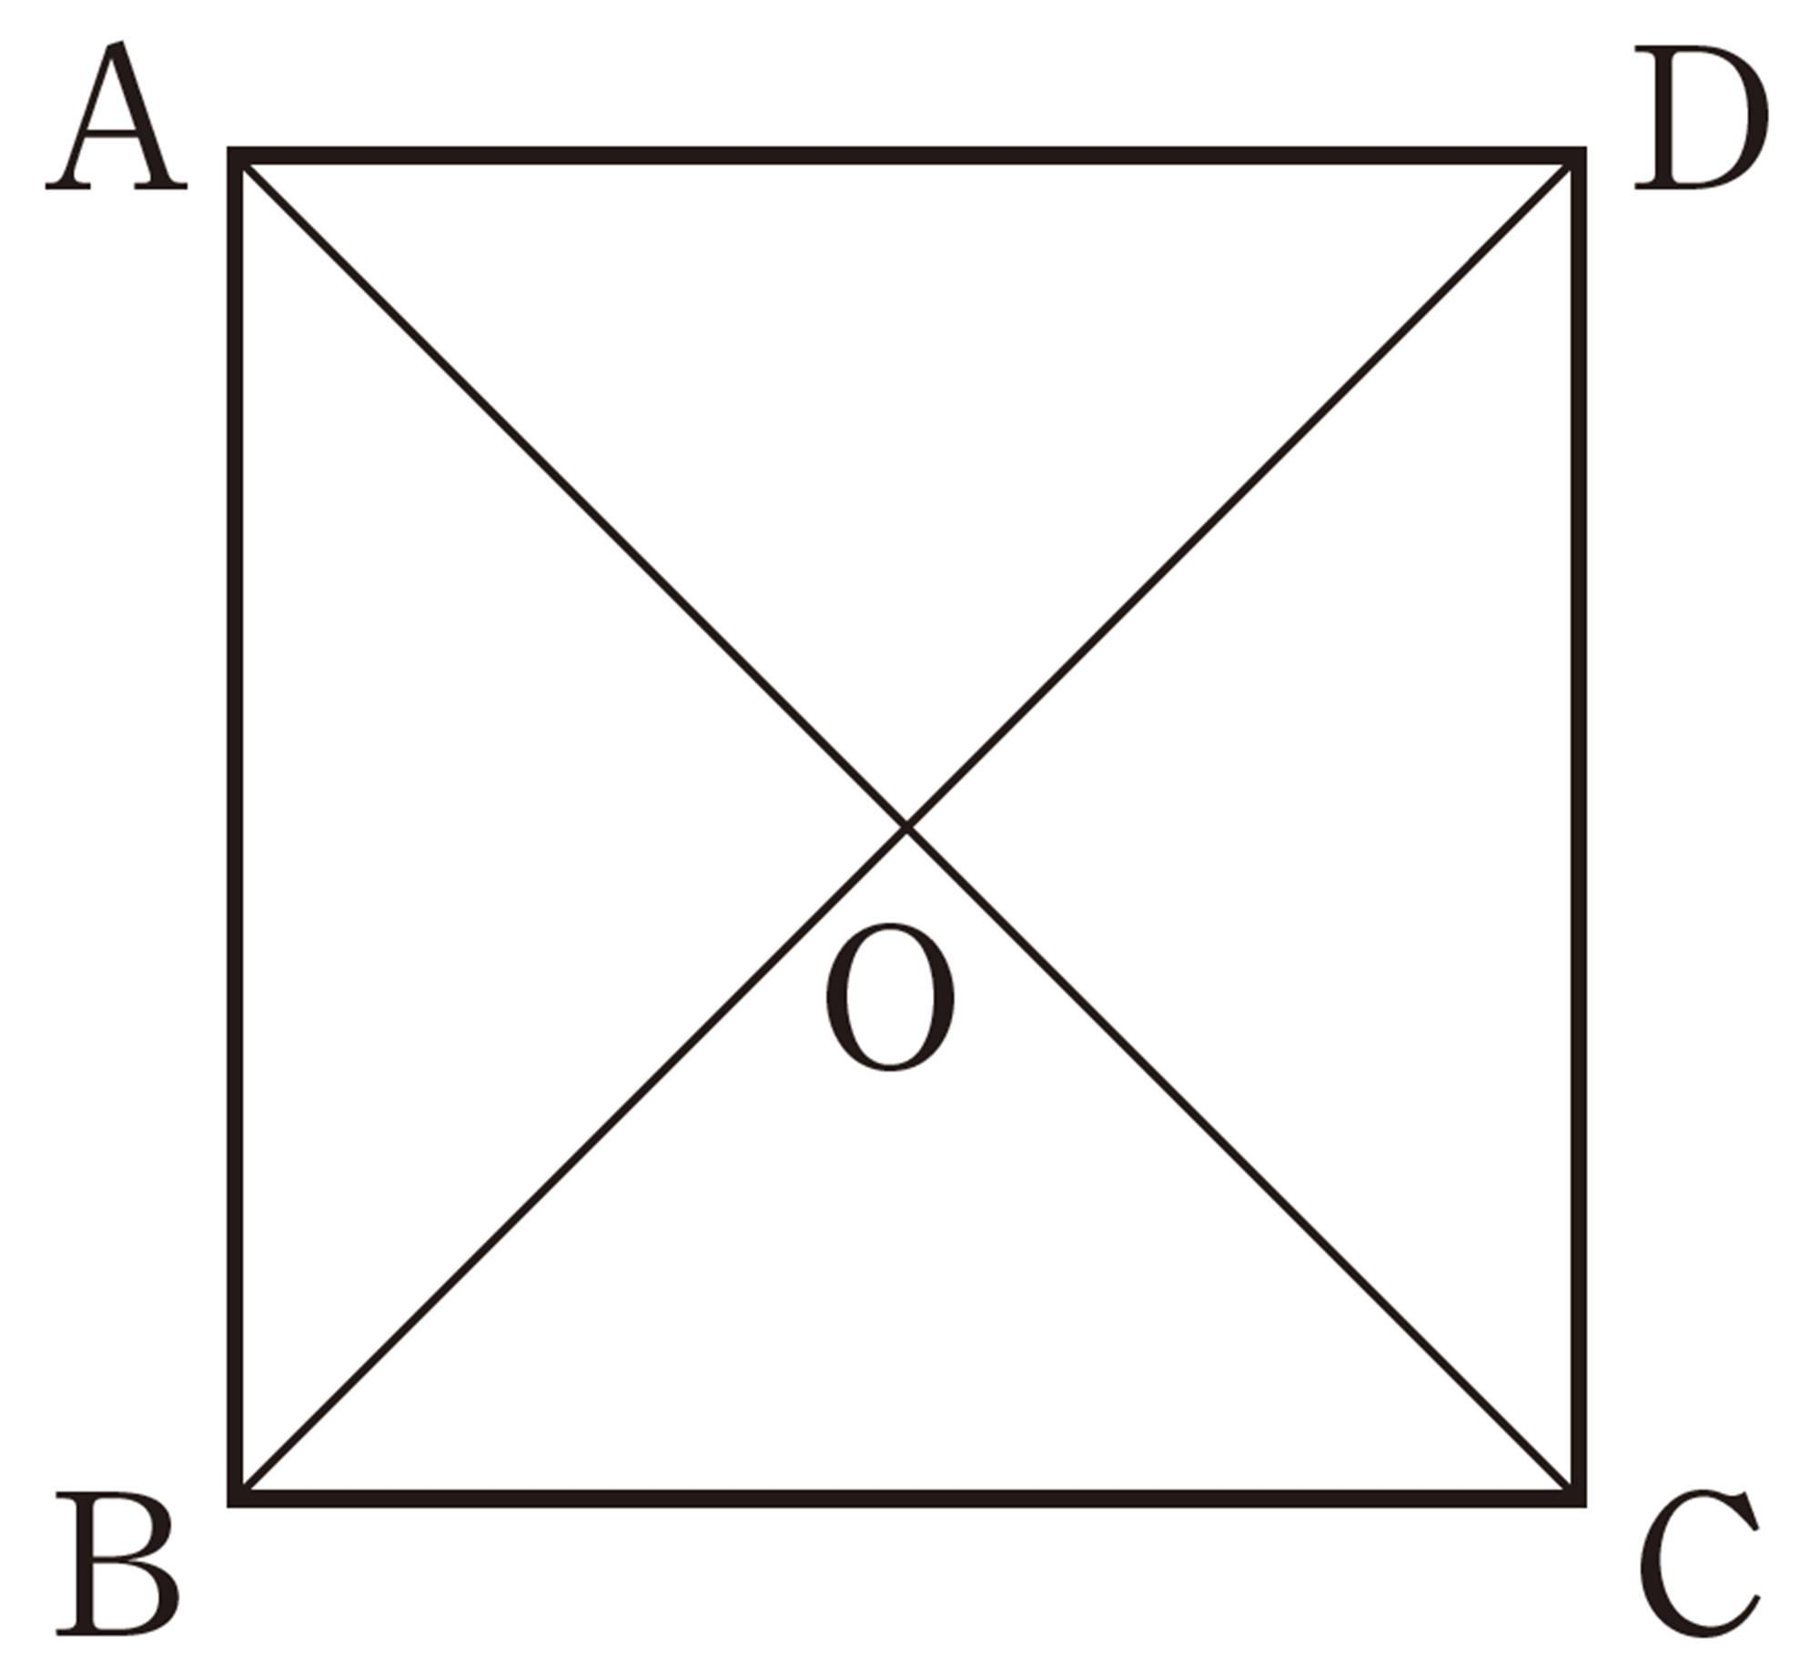
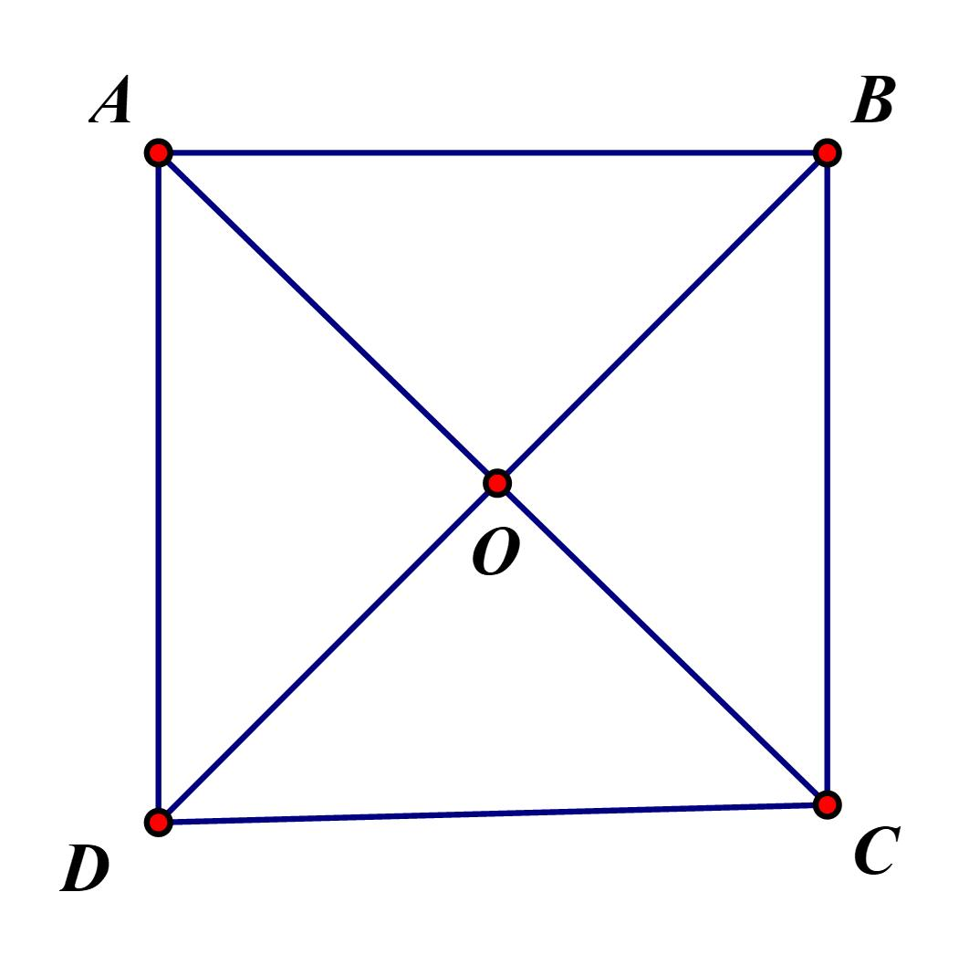
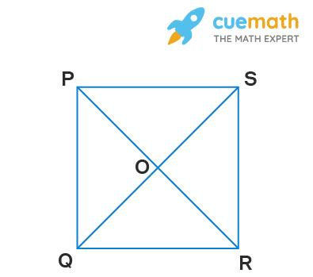
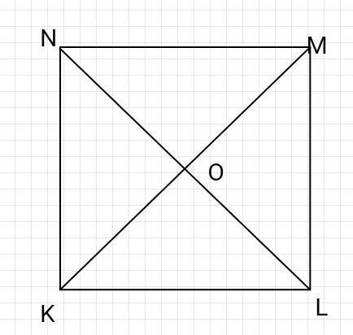
In a parallelogram, the diagonals bisect each other at their intersection.

Intersection and Angles
# Source: AI Source: Provided by: [Data Path: Persons Table -> ID Column: 1, Name_En Column: Motasem Essam] -> From: [ChatGPT] on [7/25/2026]
When two lines intersect, they form four angles.
If the lines are perpendicular:
$$\boxed{{90}^{∘}}$$
If they are not perpendicular, they form pairs of vertical angles and supplementary adjacent angles.
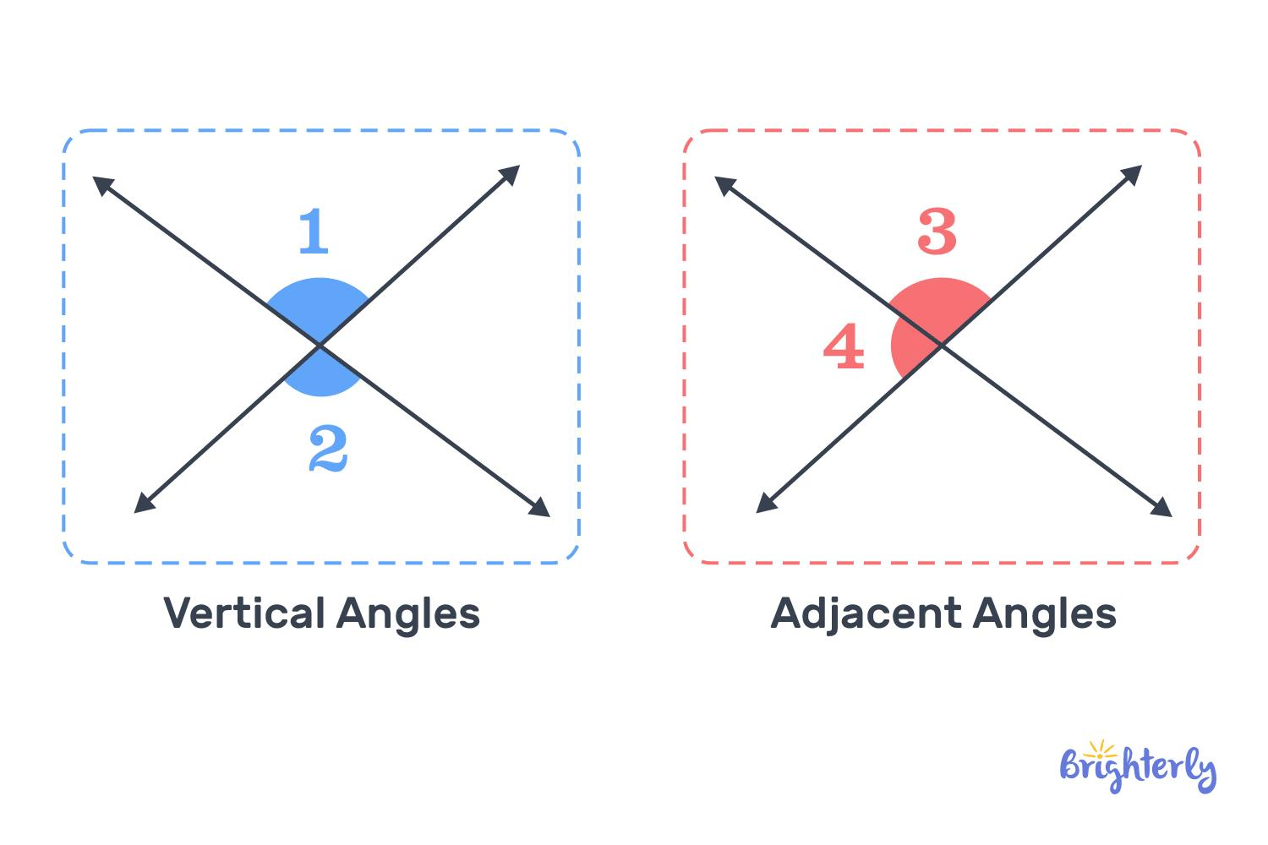
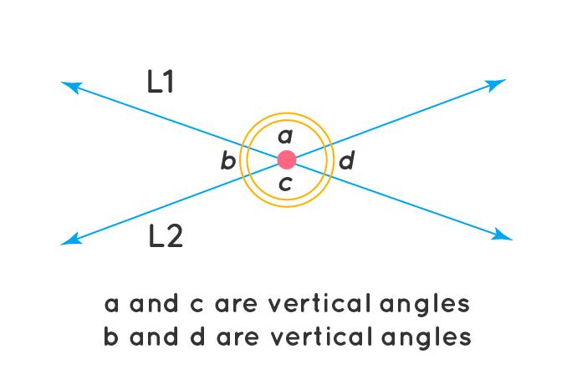
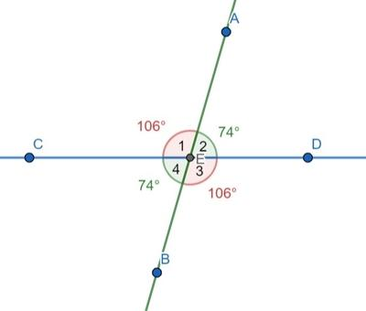
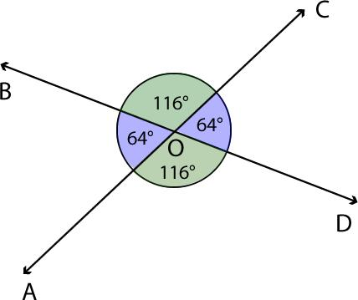
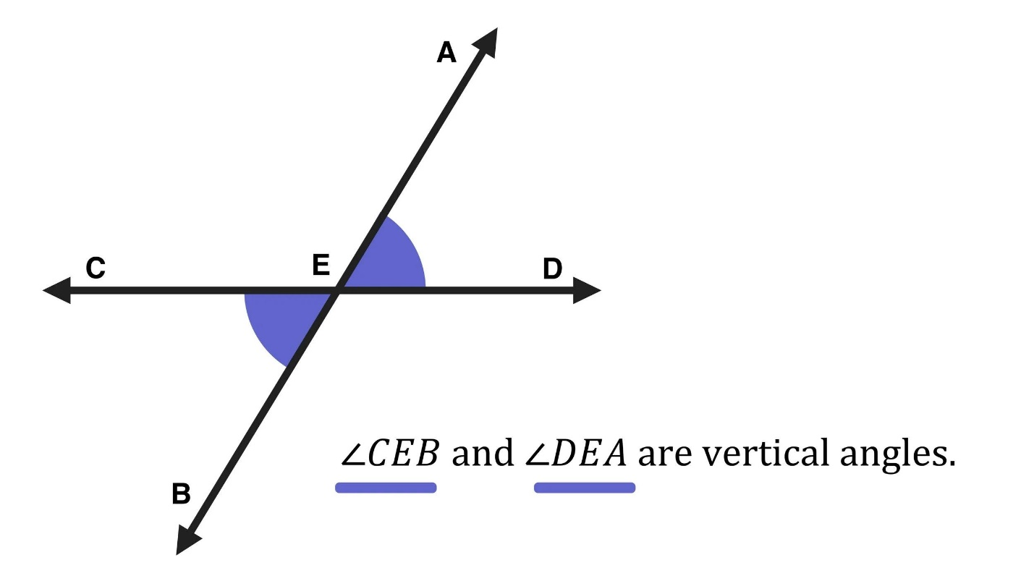

Vertical Angles
# Source: AI Source: Provided by: [Data Path: Persons Table -> ID Column: 1, Name_En Column: Motasem Essam] -> From: [ChatGPT] on [7/25/2026]
When two lines intersect, opposite angles are called vertical angles.
Vertical angles are equal.
If:
$$∠1$$
and:
$$∠3$$
are vertical angles, then:
$$\boxed{∠1=∠3}$$
Similarly:
$$\boxed{∠2=∠4}$$
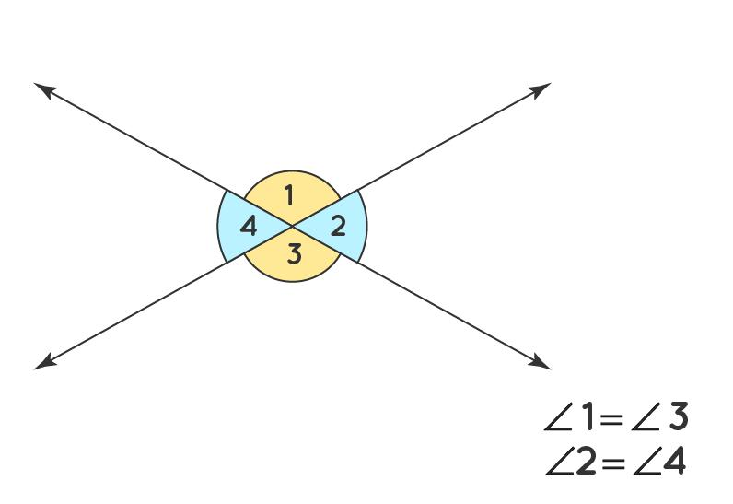
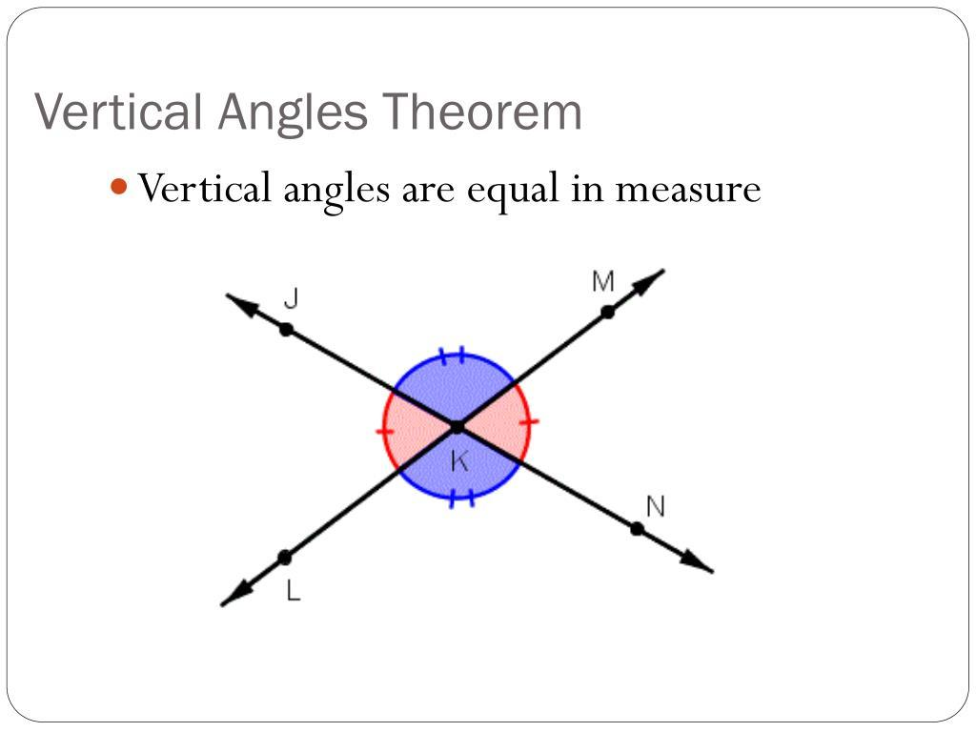
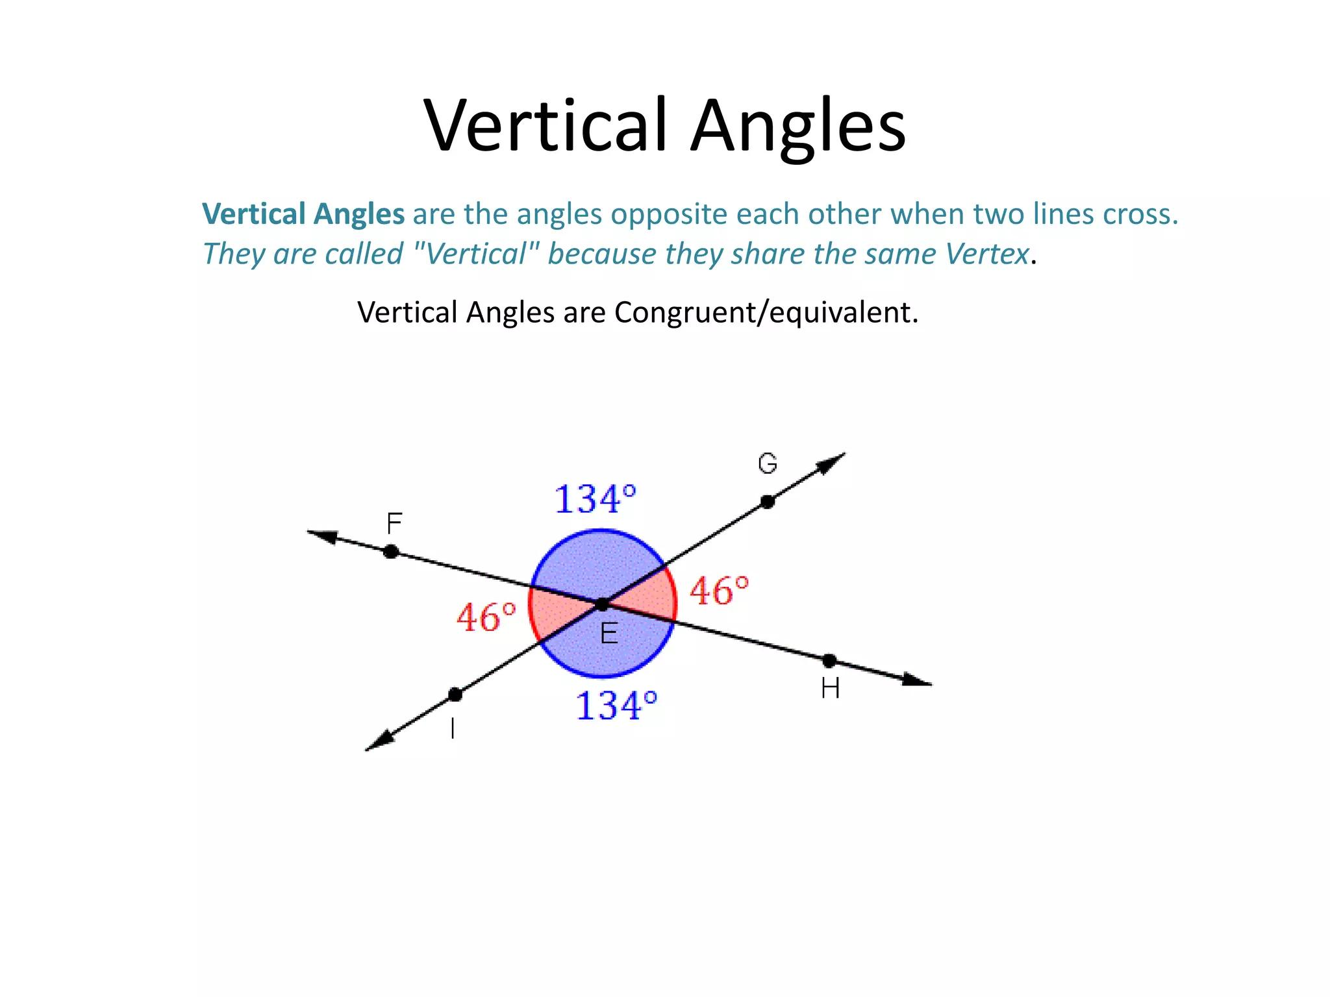

Adjacent Angles at an Intersection
# Source: AI Source: Provided by: [Data Path: Persons Table -> ID Column: 1, Name_En Column: Motasem Essam] -> From: [ChatGPT] on [7/25/2026]
Adjacent angles formed by two intersecting lines are supplementary.
Therefore:
$$\boxed{∠1+∠2={180}^{∘}}$$
For example, if:
$$∠1={70}^{∘}$$
then:
$$∠2={110}^{∘}$$
because:
$${70}^{∘}+{110}^{∘}={180}^{∘}$$

Intersection in Coordinate Geometry
# Source: AI Source: Provided by: [Data Path: Persons Table -> ID Column: 1, Name_En Column: Motasem Essam] -> From: [ChatGPT] on [7/25/2026]
Intersection is particularly important in coordinate geometry.
Two equations can be solved to find the coordinates of their intersection point.
For example:
$$y=x+1$$
and:
$$y=-x+5$$
At the intersection:
$$x+1=-x+5$$
Therefore:
$$2x=4 \\ x=2$$
Substituting:
$$y=3$$
Therefore, the intersection point is:
$$\boxed{\left(2,3\right)}$$
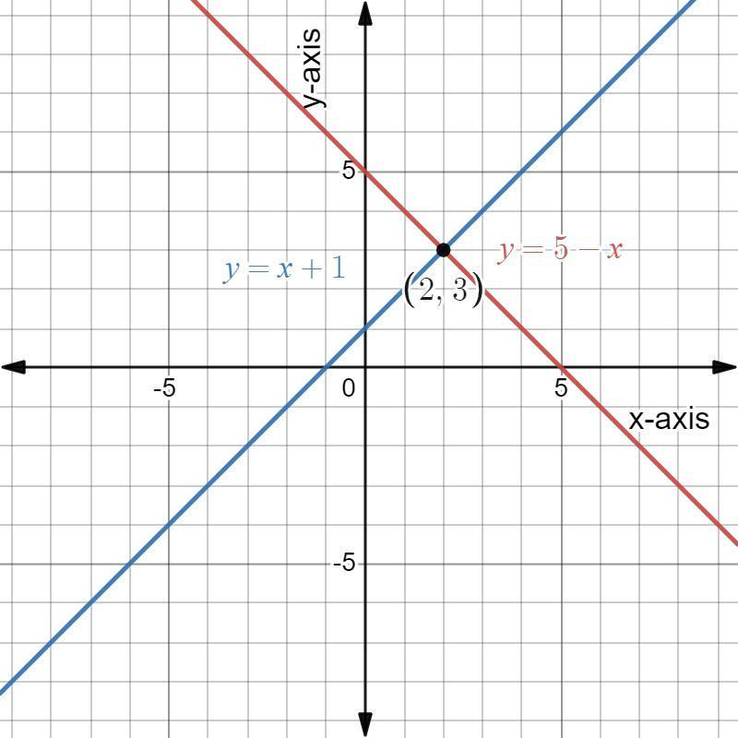
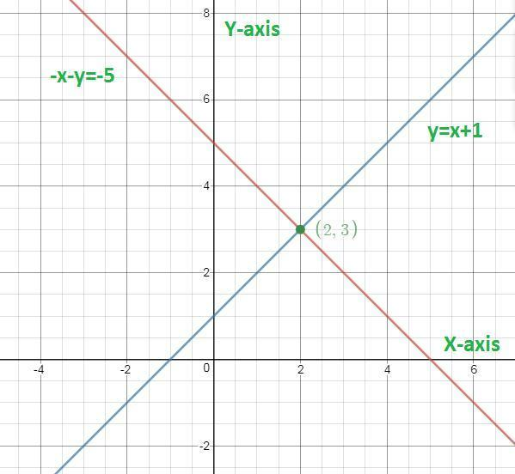

Intersection of Sets and Geometry
# Source: AI Source: Provided by: [Data Path: Persons Table -> ID Column: 1, Name_En Column: Motasem Essam] -> From: [ChatGPT] on [7/25/2026]
The geometric concept of intersection is closely related to the mathematical concept of set intersection.
For two sets $A$ and $B$:
$$\boxed{A∩B}$$
contains all elements that belong to both sets.
Similarly, for two geometric objects:
$$\boxed{G_{1}∩G_{2}}$$
contains all points belonging to both objects.
For example:
$$\boxed{l∩C=A,B}$$
means that points $A$ and $B$ belong to both the line and the circle.

Intersection vs. Union
These two concepts are different.
Intersection
Common elements:
$$\boxed{A∩B}$$
means:
Elements in both $A$ and $B$.
Union
All elements from either set:
$$\boxed{A∪B}$$
means:
Elements in $A$, $B$, or both.
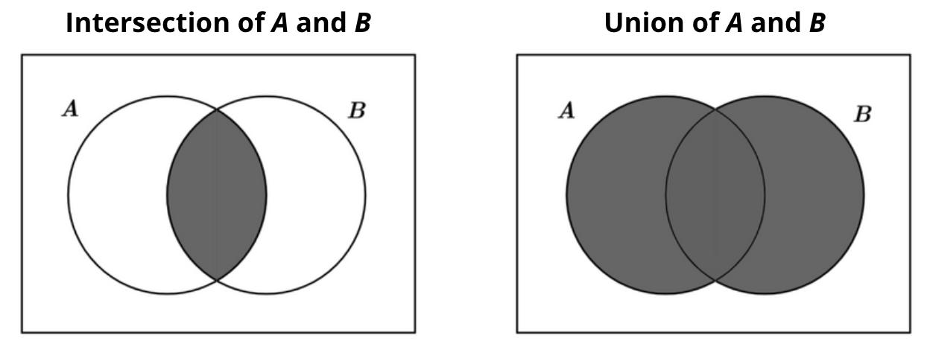
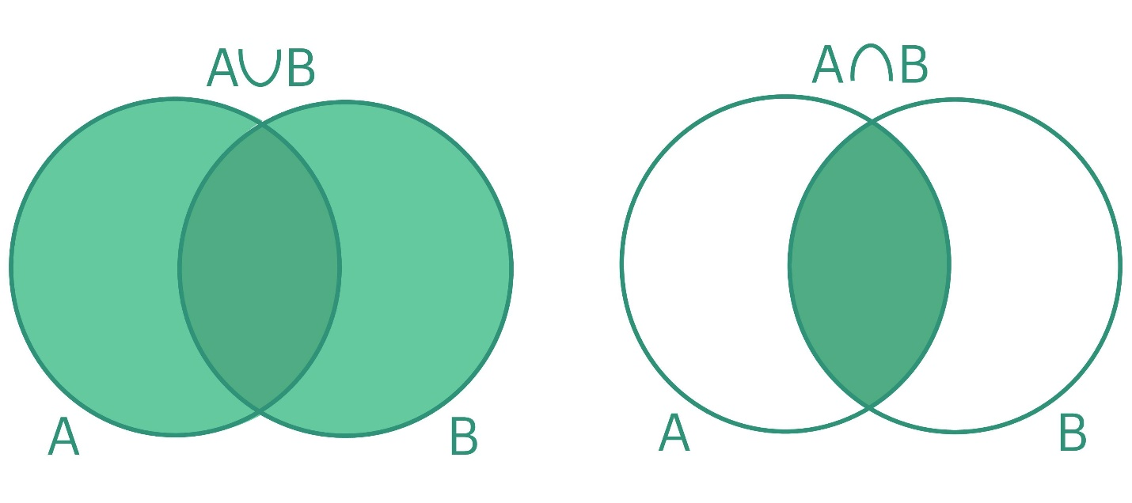
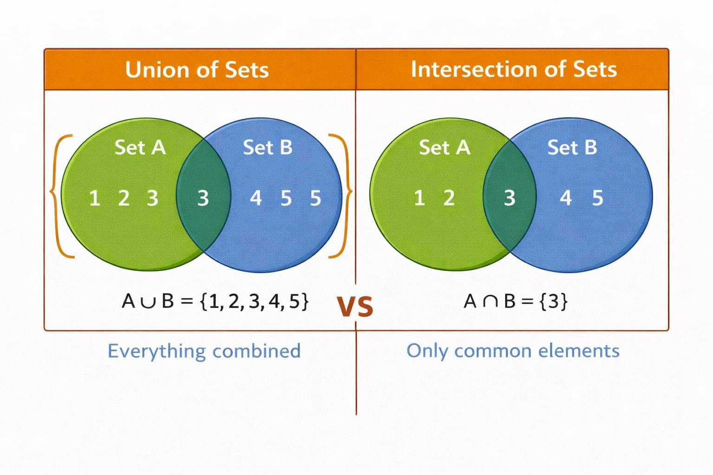

Intersection vs. Parallelism
# Source: AI Source: Provided by: [Data Path: Persons Table -> ID Column: 1, Name_En Column: Motasem Essam] -> From: [ChatGPT] on [7/25/2026]
Parallelism describes objects that do not intersect in the same plane.
Intersection
$$\boxed{l_{1}∩l_{2}=P}$$
Parallelism
$$\boxed{l_{1}∥l_{2}}$$
and:
$$\boxed{l_{1}∩l_{2}=∅}$$
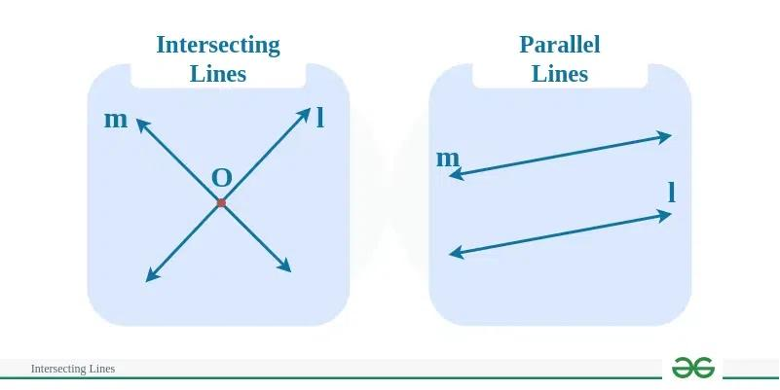
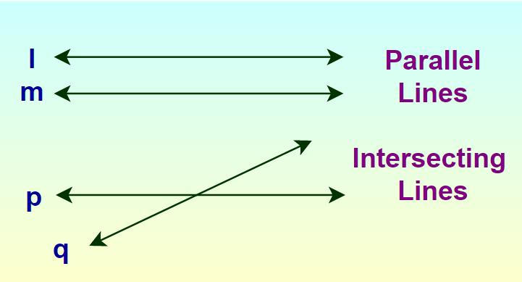
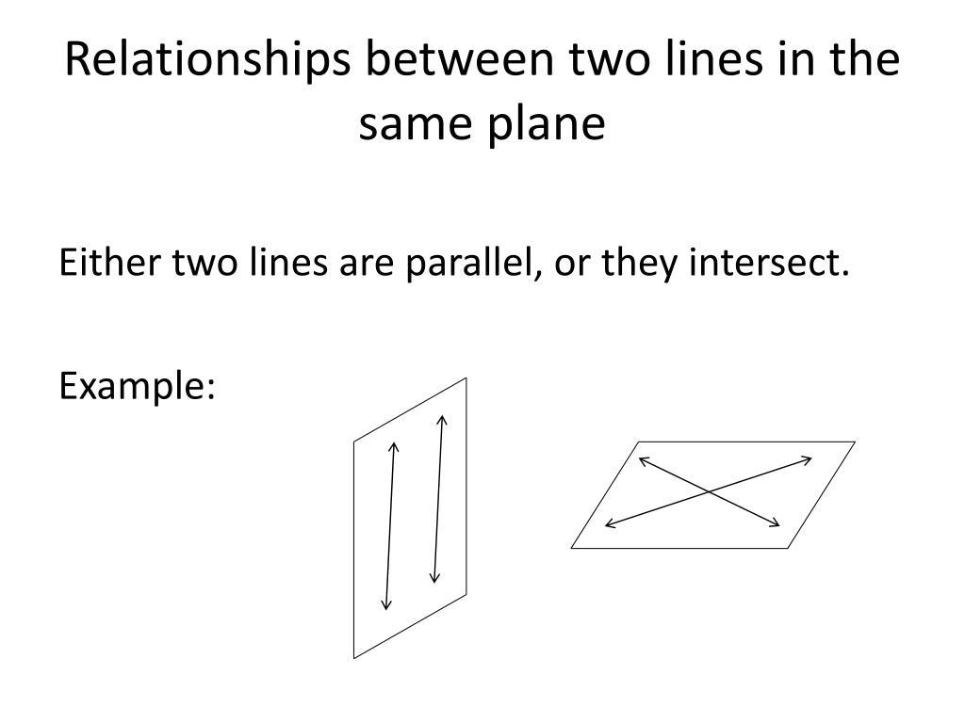

Intersection vs. Perpendicularity
# Source: AI Source: Provided by: [Data Path: Persons Table -> ID Column: 1, Name_En Column: Motasem Essam] -> From: [ChatGPT] on [7/25/2026]
Intersection is a general relationship describing objects that meet.
Perpendicularity is a special relationship in which the objects intersect at:
$$\boxed{{90}^{∘}}$$
Therefore:
$$\boxed{\text{Perpendicularity}⇒\text{Intersection}}$$
but:
$$\boxed{\text{Intersection}⇏\text{Perpendicularity}}$$
For example, two lines intersecting at ${60}^{∘}$ have an intersection but are not perpendicular.
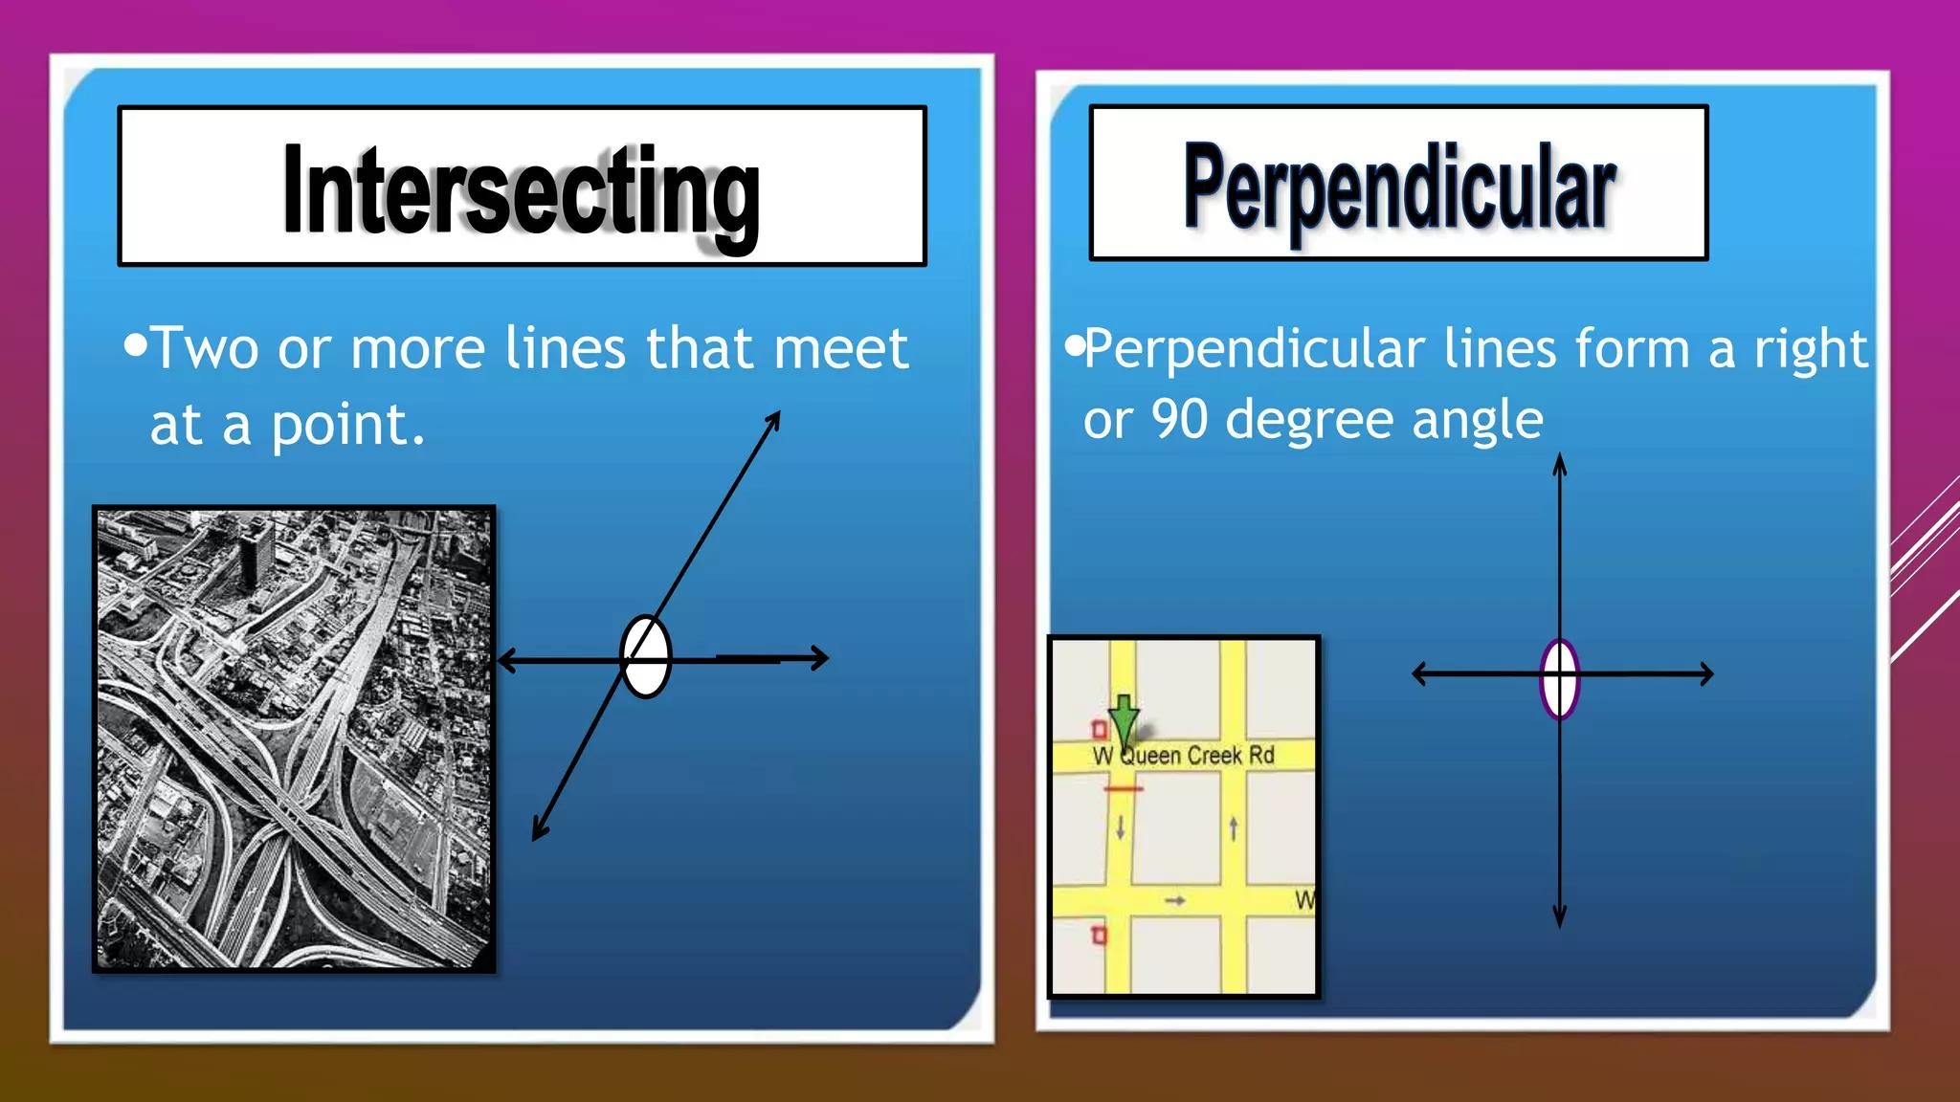
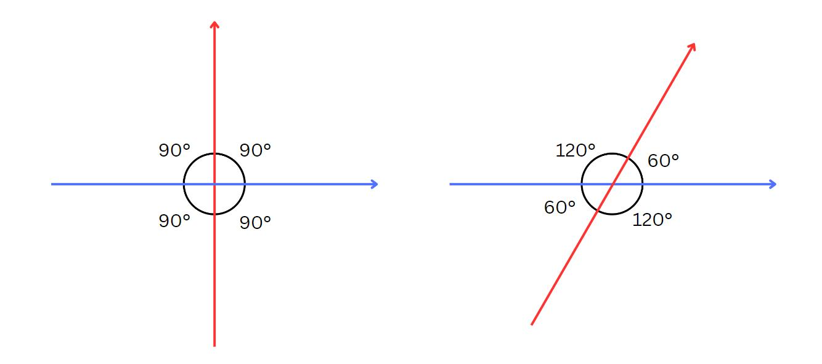
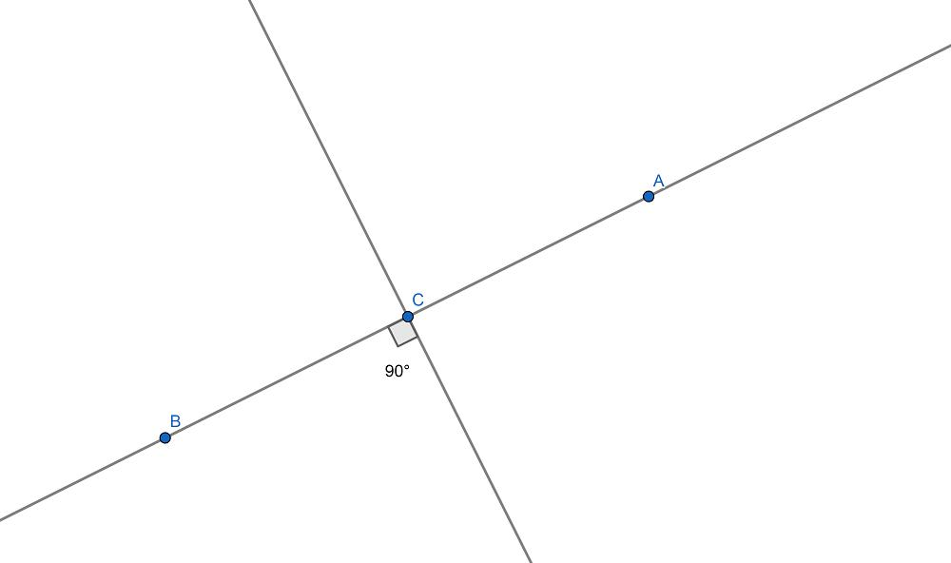

Intersection in Architecture
# Source: AI Source: Provided by: [Data Path: Persons Table -> ID Column: 1, Name_En Column: Motasem Essam] -> From: [ChatGPT] on [7/25/2026]
Intersections occur where structural or design elements meet.
Examples include:
- Walls.
- Beams.
- Roads.
- Roof structures.
- Floor plans.
- Structural frames.
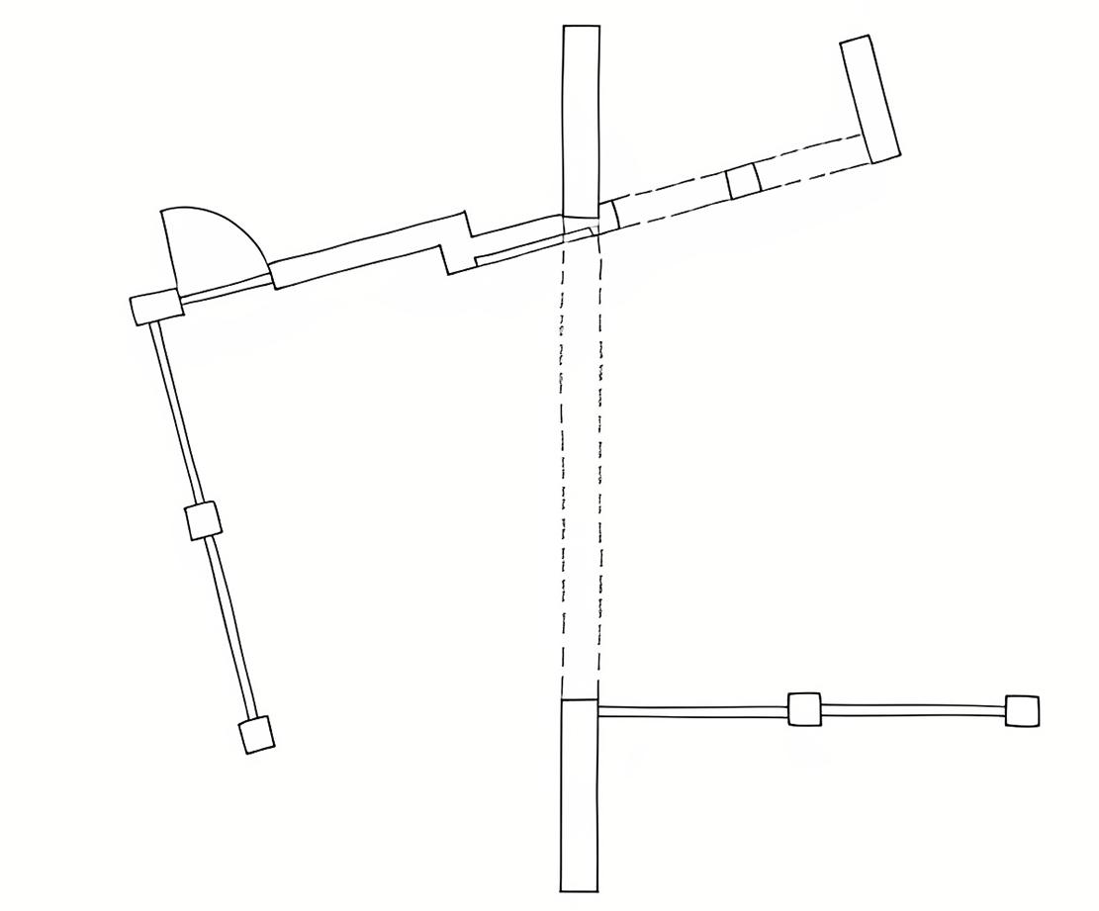
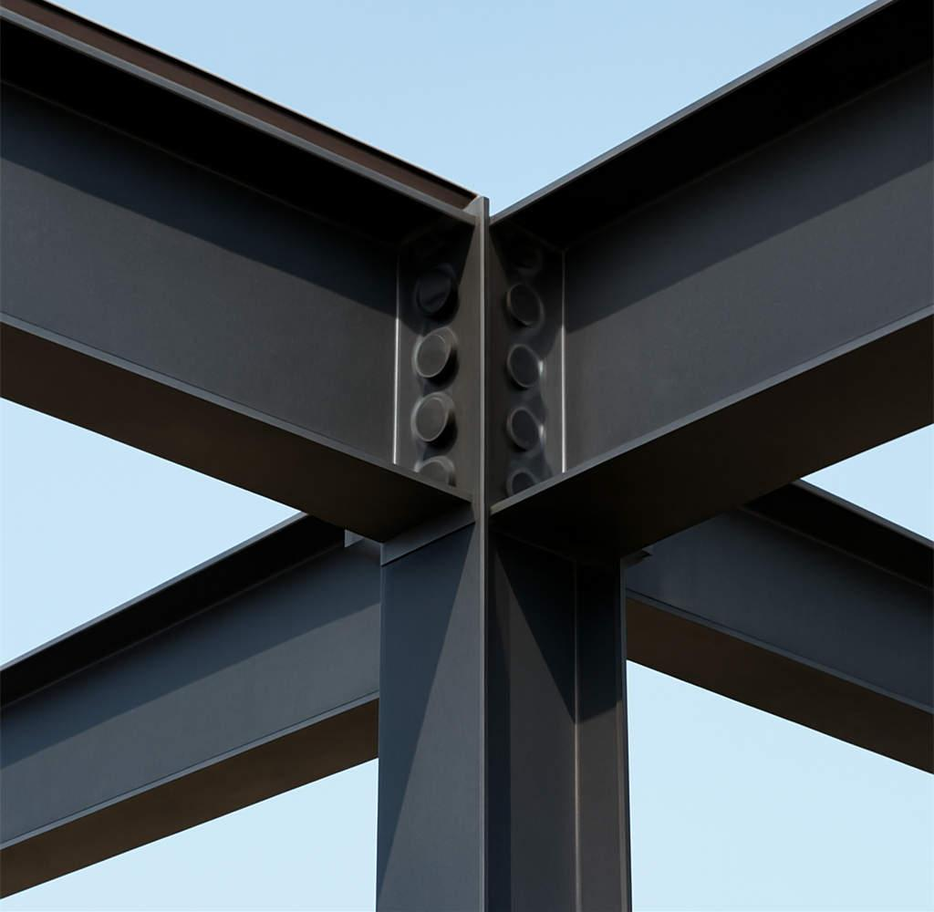
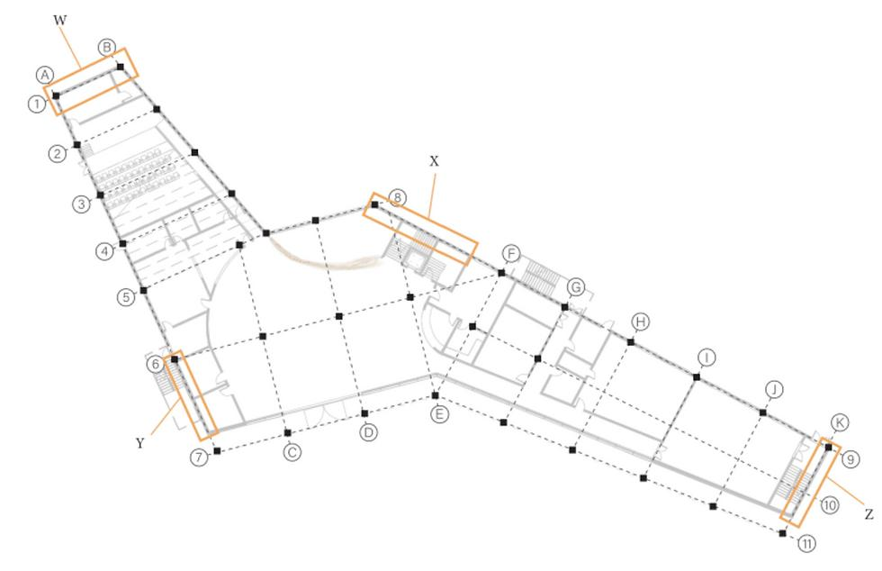
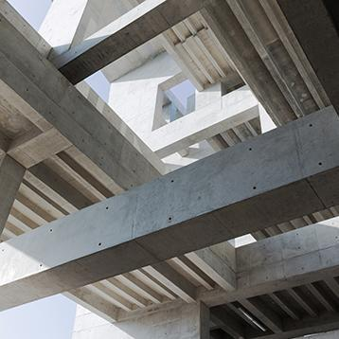


Intersection in Engineering
# Source: AI Source: Provided by: [Data Path: Persons Table -> ID Column: 1, Name_En Column: Motasem Essam] -> From: [ChatGPT] on [7/25/2026]
Engineers analyze intersections between:
- Structural members.
- Machine components.
- Roads.
- Pipes.
- Mechanical parts.
- Technical drawing elements.
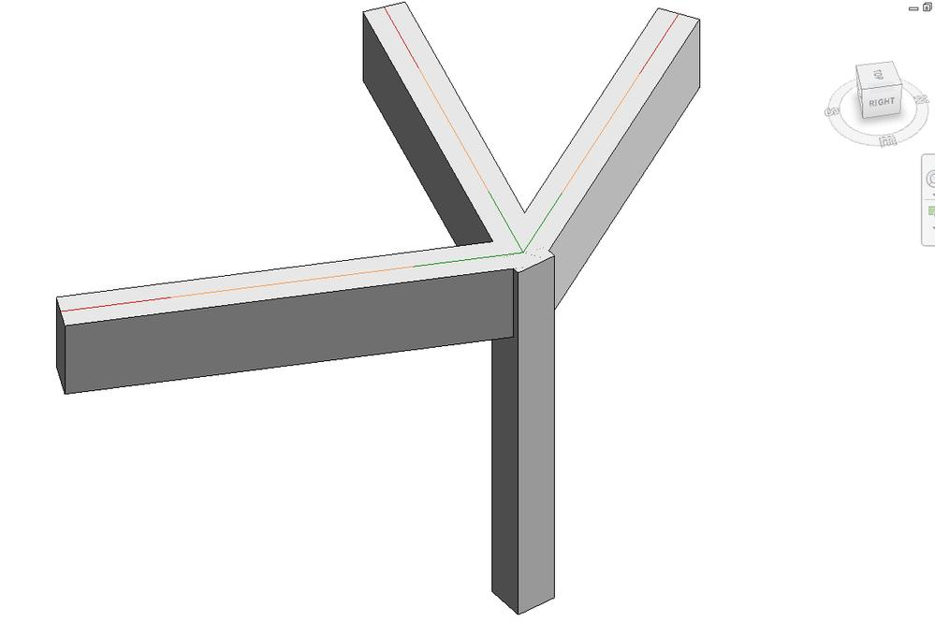
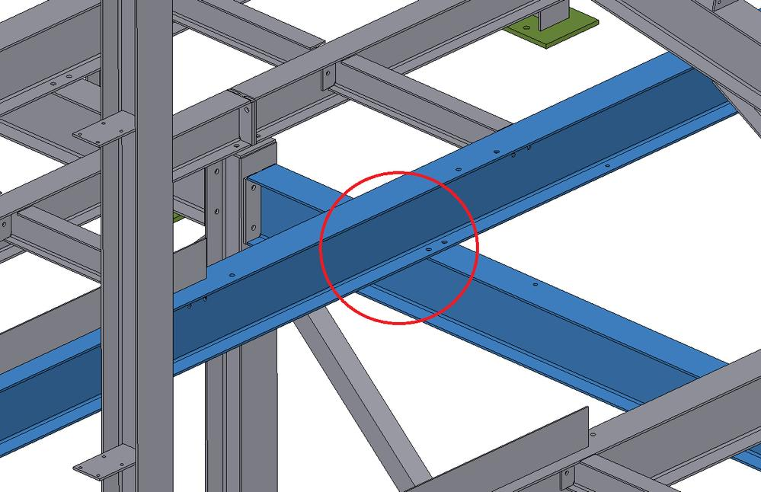
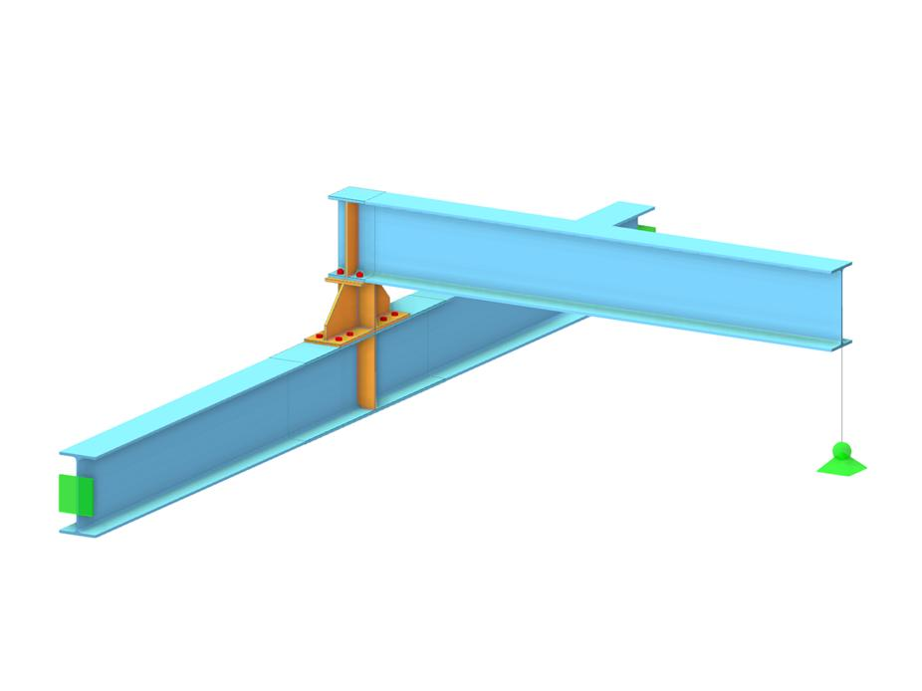
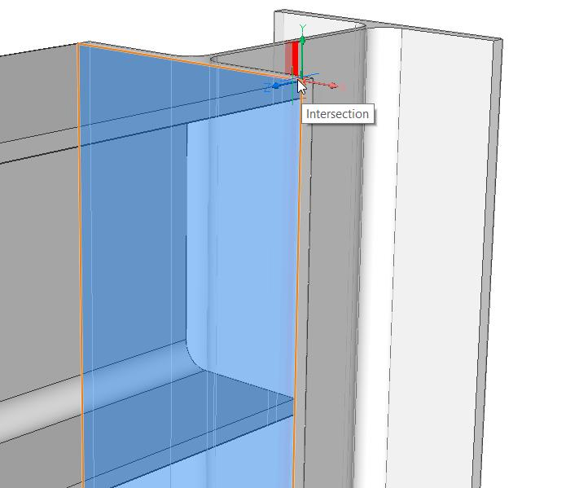
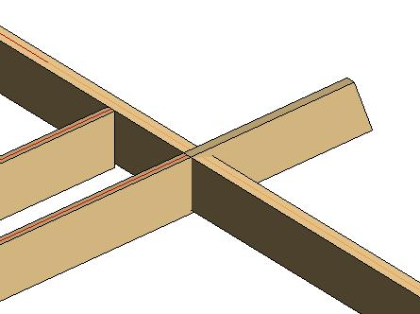
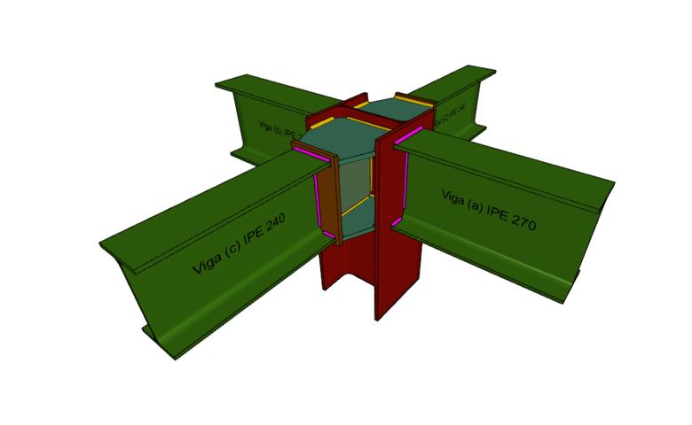

Intersection in CAD
# Source: AI Source: Provided by: [Data Path: Persons Table -> ID Column: 1, Name_En Column: Motasem Essam] -> From: [ChatGPT] on [7/25/2026]
CAD systems use geometric intersections to determine where objects meet.
For example:
- Line–line intersection.
- Line–circle intersection.
- Circle–circle intersection.
- Arc–line intersection.
- Surface intersection.
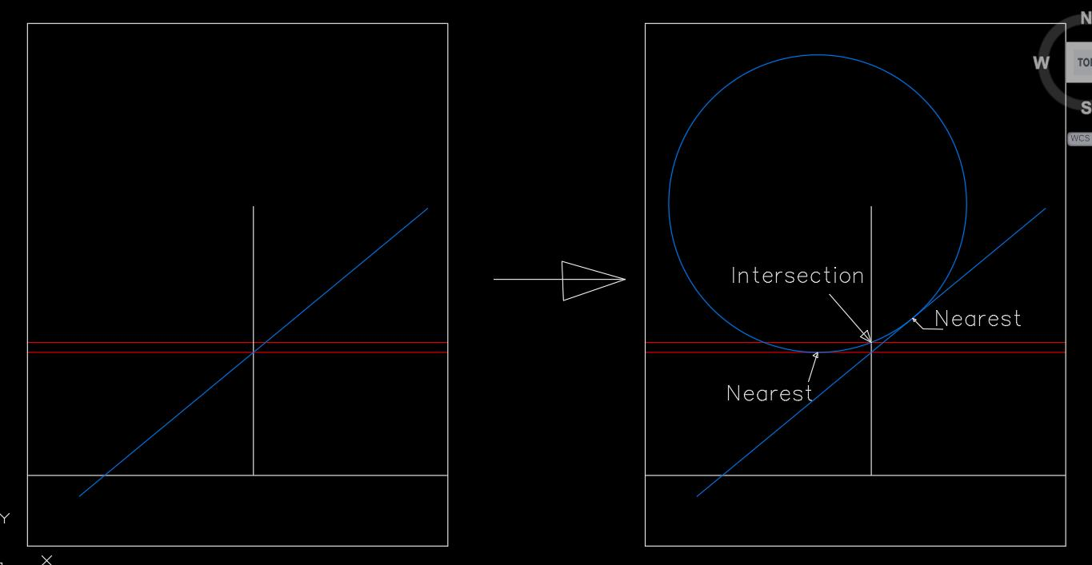
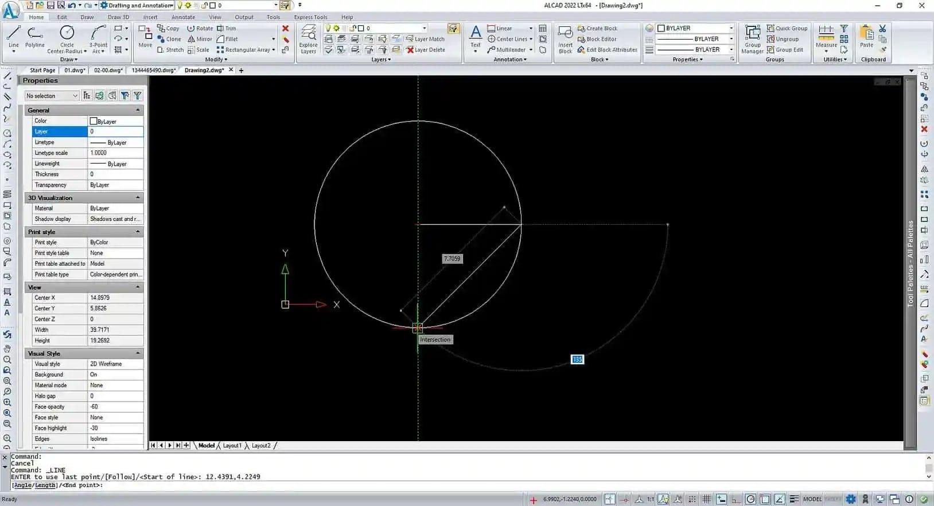
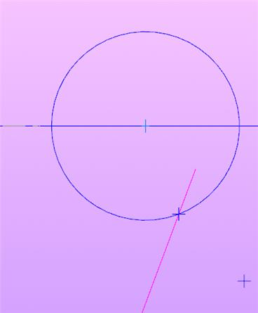
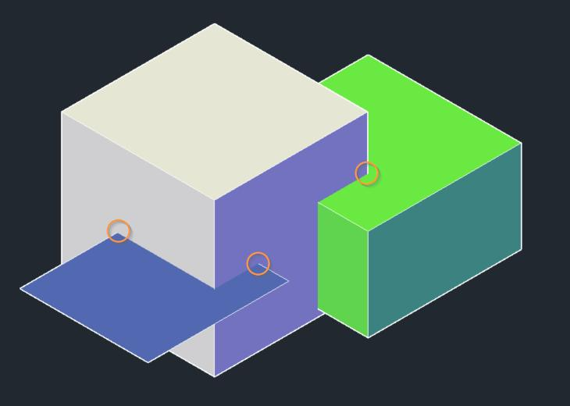

Intersection in Surveying and Mapping
# Source: AI Source: Provided by: [Data Path: Persons Table -> ID Column: 1, Name_En Column: Motasem Essam] -> From: [ChatGPT] on [7/25/2026]
Intersections are useful for determining locations.
For example, the intersection of two measured lines can identify a point on a map.
This principle is used in:
- Surveying.
- Triangulation.
- Cartography.
- GPS-related positioning.
- Geographic information systems.
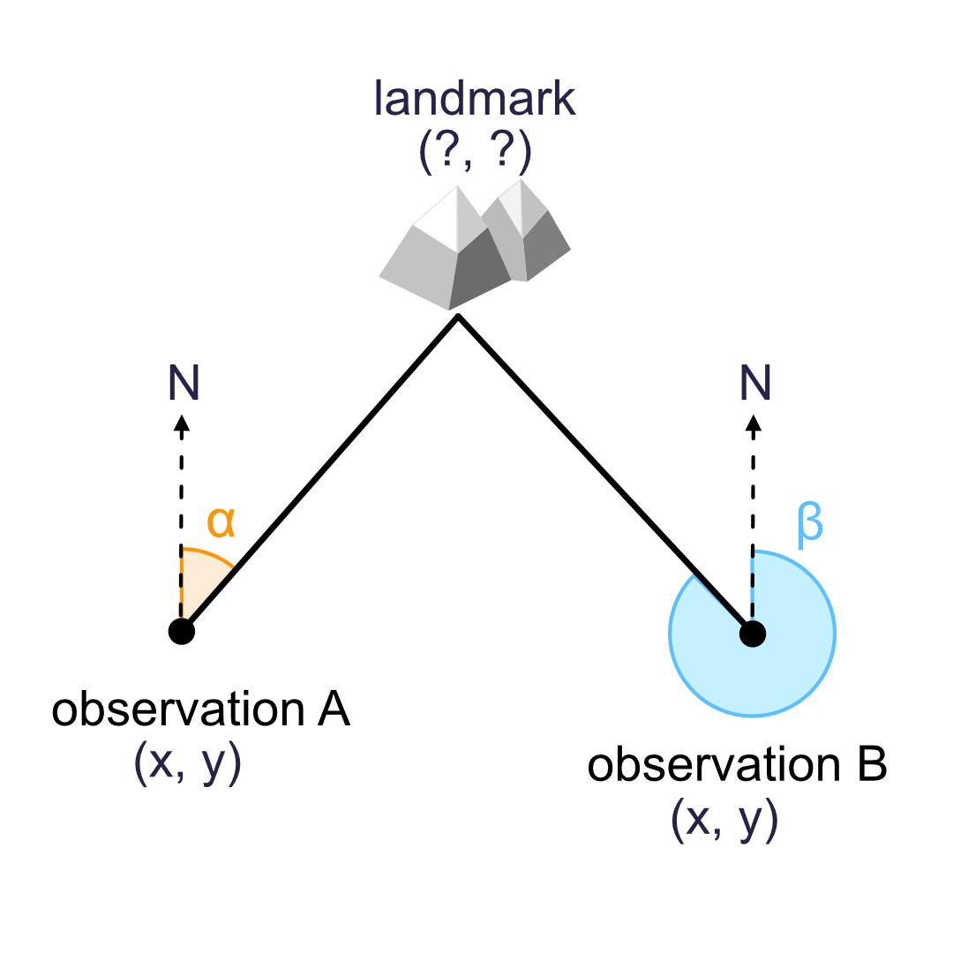
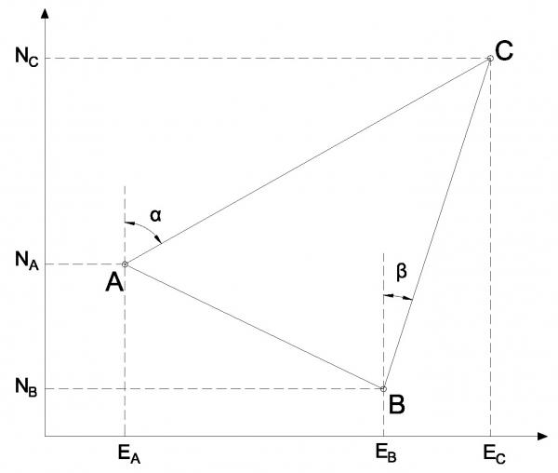
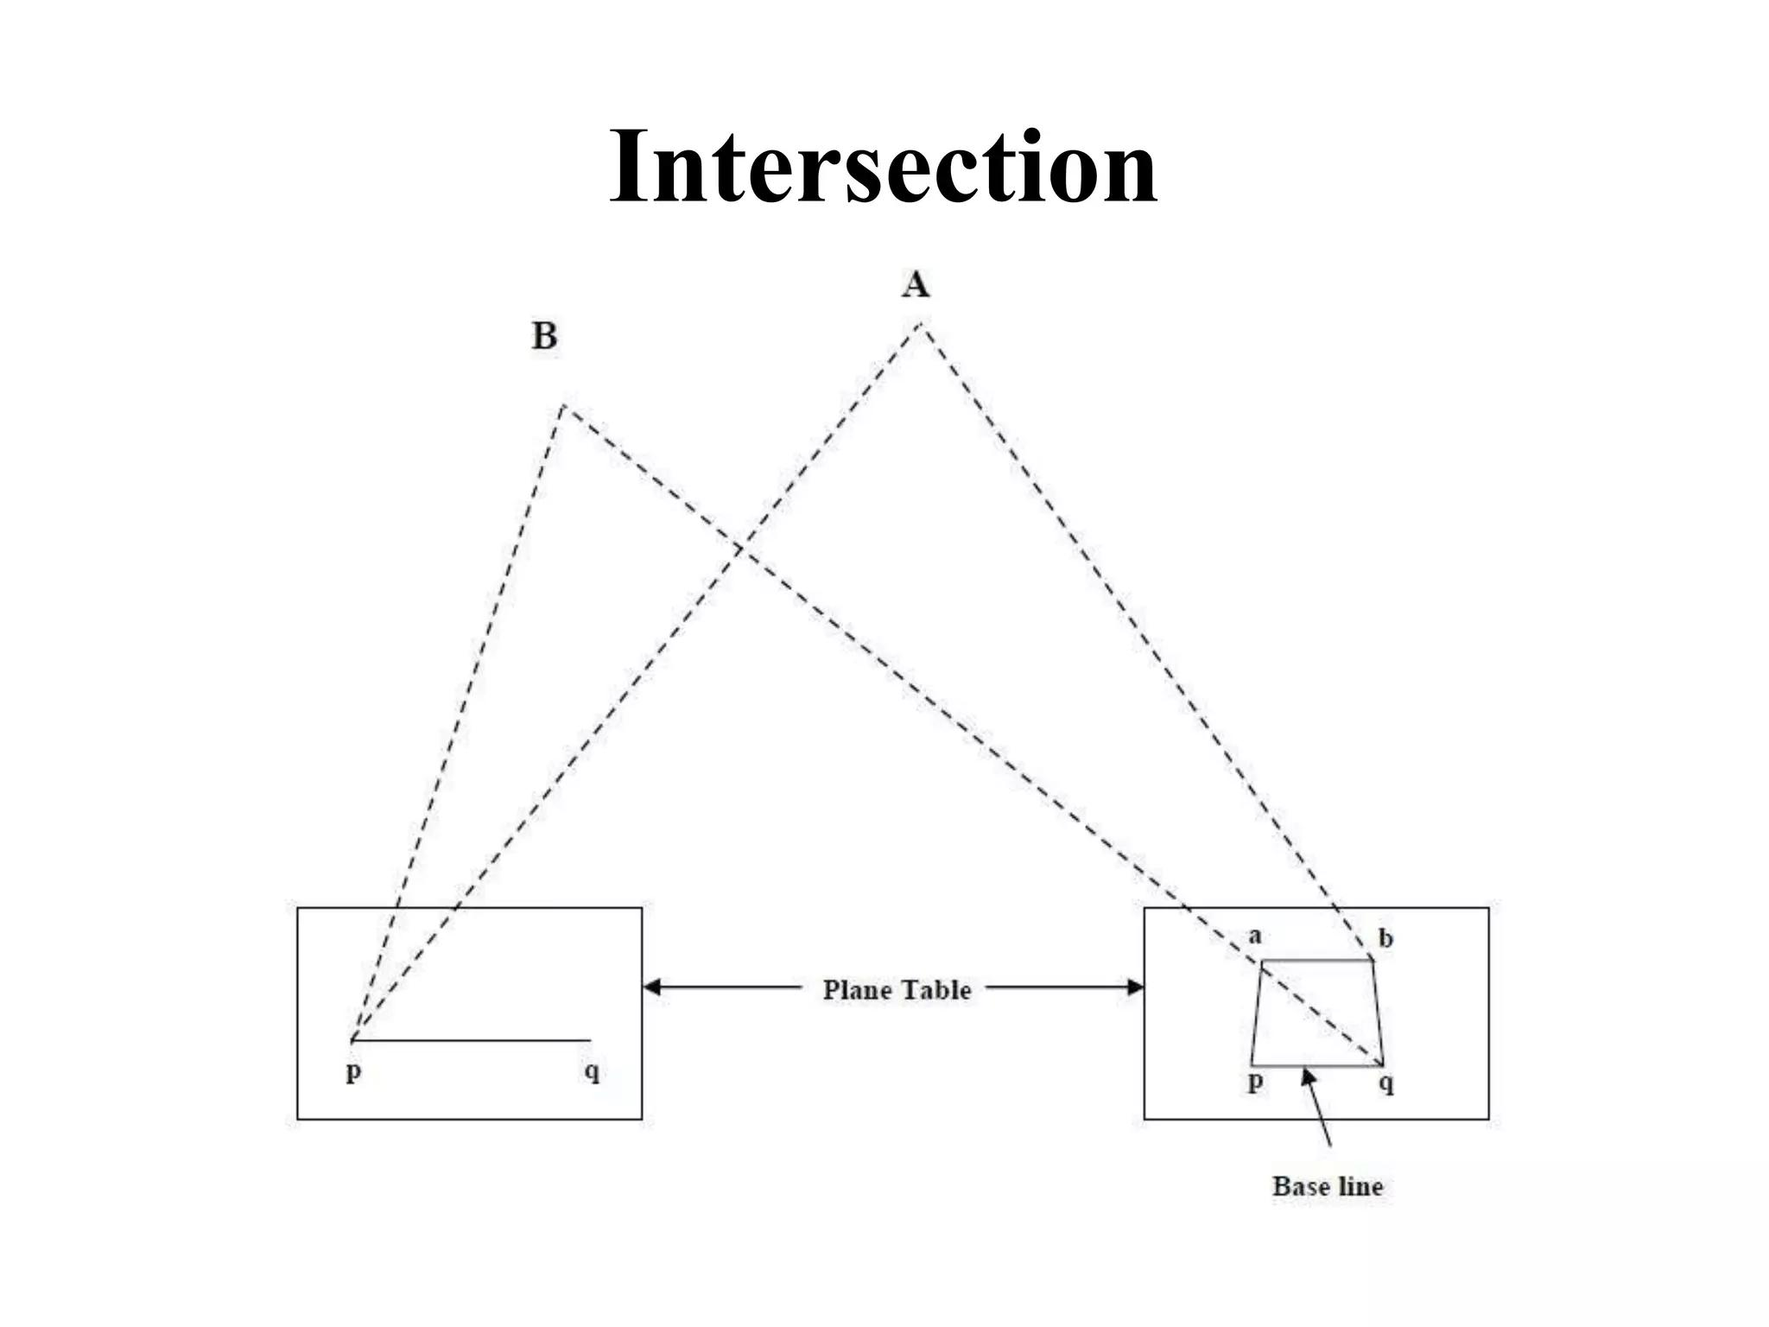
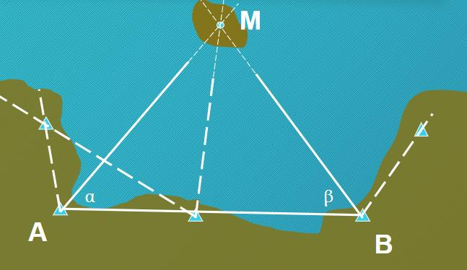
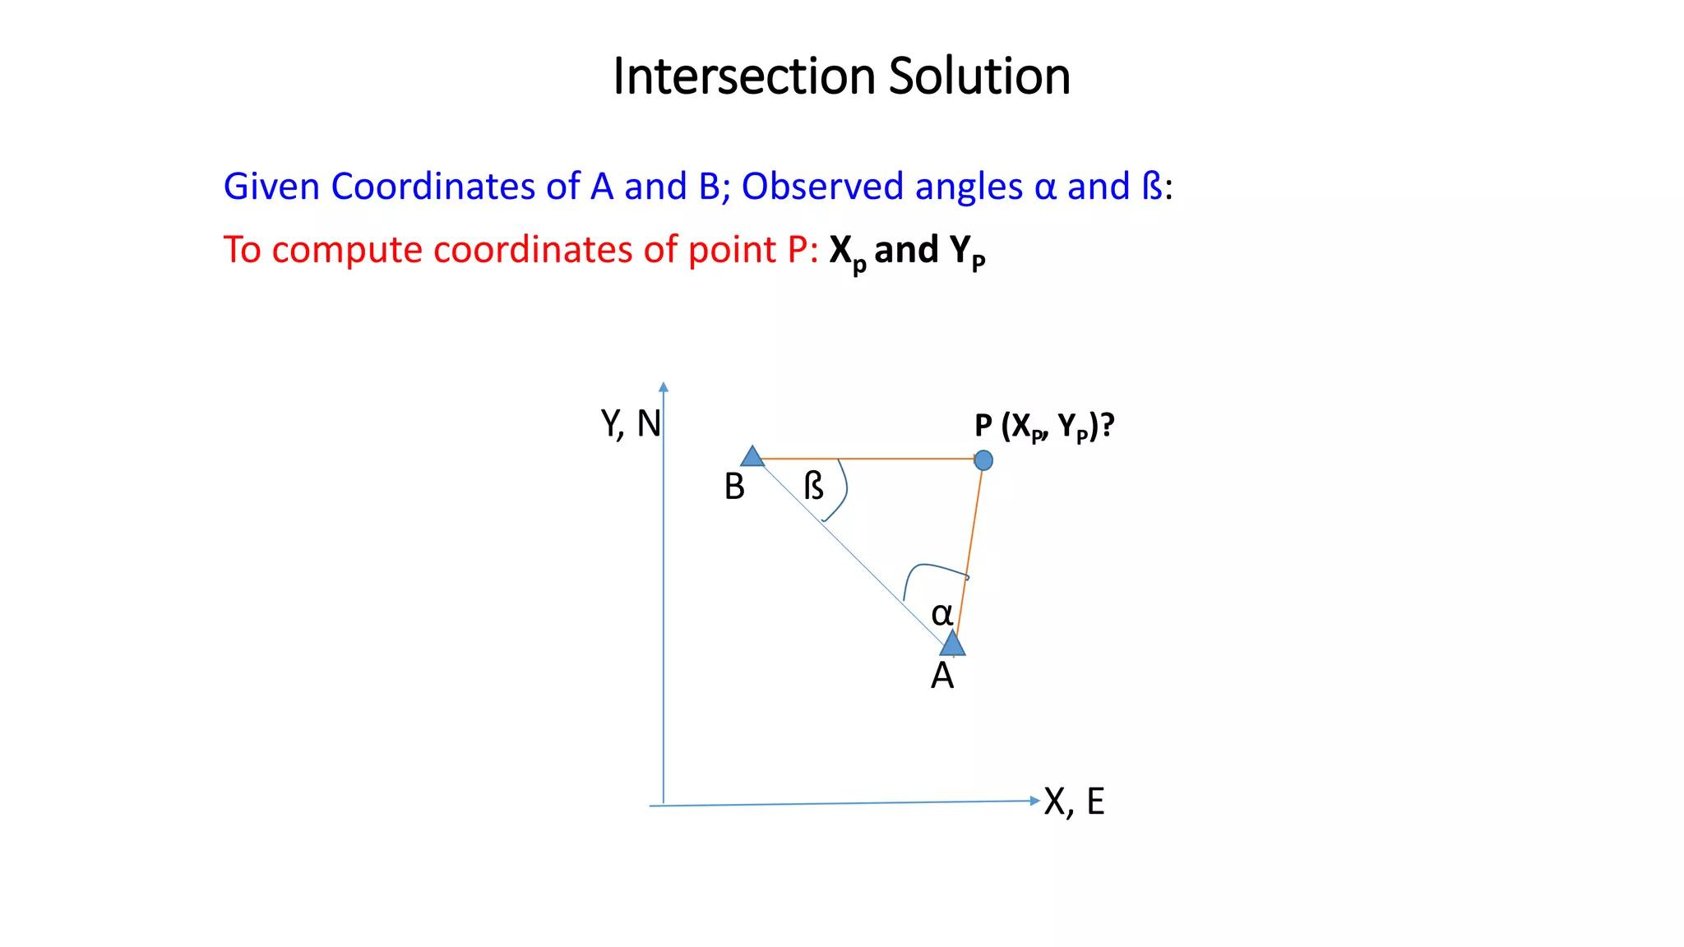
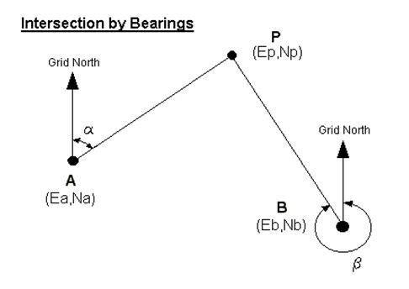

Real-World Examples
# Source: AI Source: Provided by: [Data Path: Persons Table -> ID Column: 1, Name_En Column: Motasem Essam] -> From: [ChatGPT] on [7/25/2026]
Examples of geometric intersections include:
- Two roads crossing.
- Two streets meeting.
- Railway tracks crossing.
- Two walls meeting at a corner.
- The crossing of two wires.
- The intersection of lines on a map.
- The crossing of diagonals in a geometric figure.
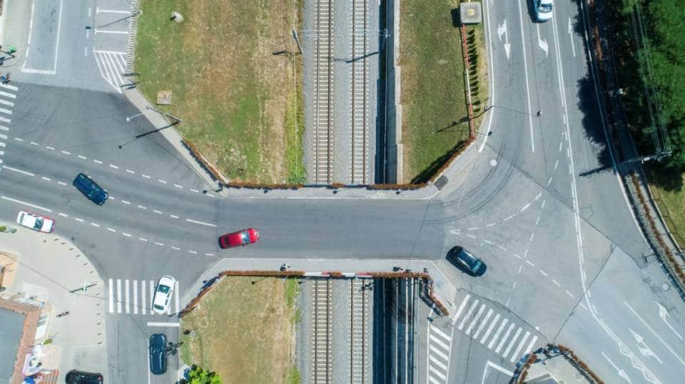
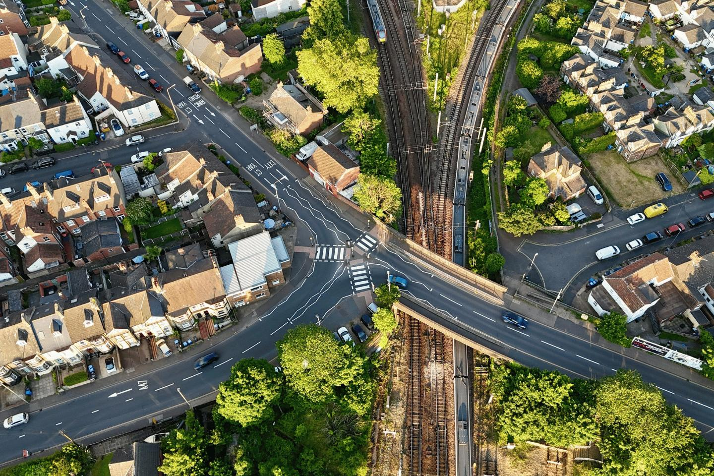
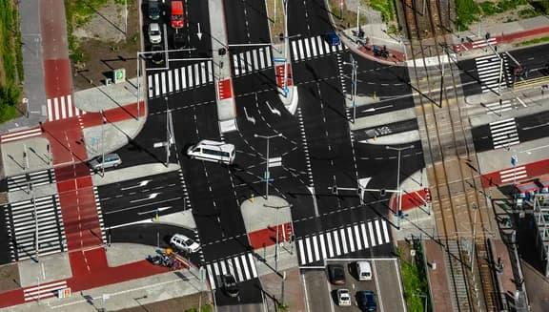
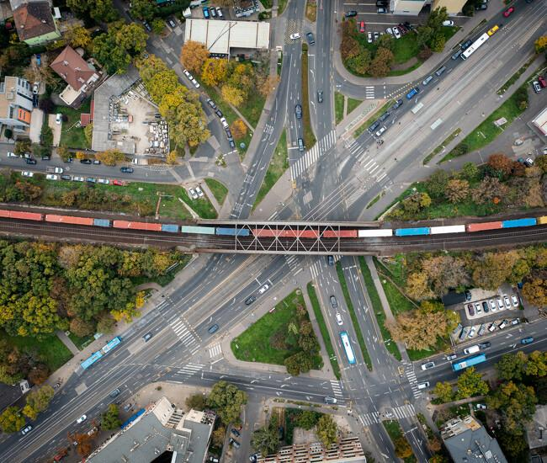
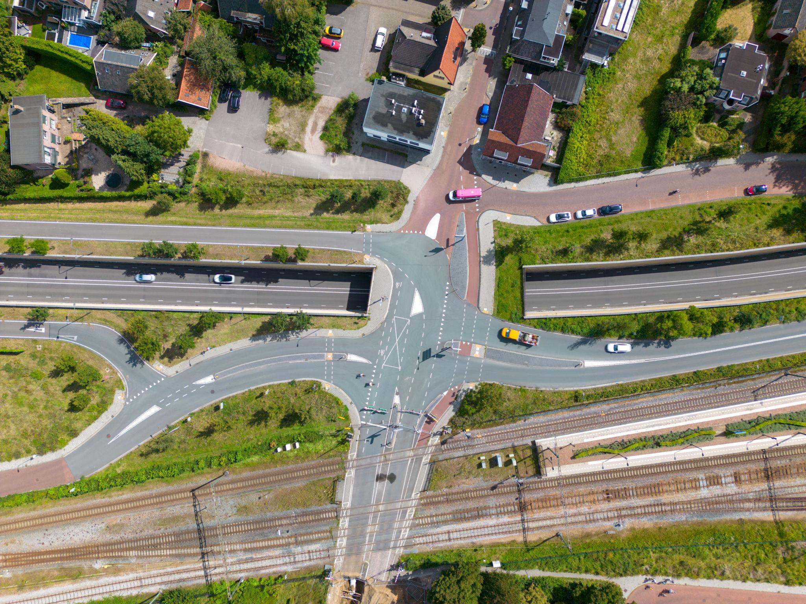

Applications
# Source: AI Source: Provided by: [Data Path: Persons Table -> ID Column: 1, Name_En Column: Motasem Essam] -> From: [ChatGPT] on [7/25/2026]
Intersection is important in:
- Plane Geometry
- Coordinate Geometry
- Euclidean Geometry
- Set Theory
- Algebra
- Trigonometry
- Architecture
- Engineering
- Surveying
- Cartography
- CAD
- Computer Graphics
- GIS
- Robotics

Advantages
# Source: AI Source: Provided by: [Data Path: Persons Table -> ID Column: 1, Name_En Column: Motasem Essam] -> From: [ChatGPT] on [7/25/2026]
Studying intersection helps to:
- Identify common points.
- Analyze geometric relationships.
- Solve systems of equations.
- Determine unknown coordinates.
- Analyze angles.
- Study polygon diagonals.
- Determine crossing locations.
- Construct geometric figures.
- Calculate intersections between curves.
- Model real-world objects and paths.

Limitations
# Source: AI Source: Provided by: [Data Path: Persons Table -> ID Column: 1, Name_En Column: Motasem Essam] -> From: [ChatGPT] on [7/25/2026]
Intersection:
- Does not necessarily mean that objects cross at (90^\circ).
- Can involve zero, one, two, or infinitely many common points.
- Can become complicated for complex curves or surfaces.
- In three-dimensional geometry, objects may appear close without actually intersecting.
- Requires careful analysis when geometric objects overlap or coincide.

Comparison with Related Concepts
# Source: AI Source: Provided by: [Data Path: Persons Table -> ID Column: 1, Name_En Column: Motasem Essam] -> From: [ChatGPT] on [7/25/2026]
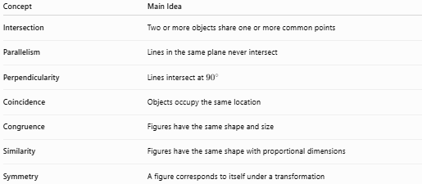
Concept | Main Idea
Intersection | Two or more objects share one or more common points
Parallelism | Lines in the same plane never intersect
Perpendicularity | Lines intersect at ${90}^{∘}$
Coincidence | Objects occupy the same location
Congruence | Figures have the same shape and size
Similarity | Figures have the same shape with proportional dimensions
Symmetry | A figure corresponds to itself under a transformation

Key Points
# Source: AI Source: Provided by: [Data Path: Persons Table -> ID Column: 1, Name_En Column: Motasem Essam] -> From: [ChatGPT] on [7/25/2026]
- Intersection occurs when two or more geometric objects have one or more common points.
- The intersection symbol is:
$$\boxed{∩}$$
- Two distinct non-parallel lines normally intersect at one point.
- Parallel lines have no intersection:
$$\boxed{l_{1}∩l_{2}=∅}$$
- Coincident lines have infinitely many common points.
- A line and a circle can have $0$, $1$, or $2$ intersection points.
- Perpendicularity is a special type of intersection:
$$\boxed{\text{Perpendicularity}⇒\text{Intersection at }{90}^{∘}}$$
- Intersecting lines create vertical angles.
- Vertical angles are equal.
- Intersection is fundamental to coordinate geometry, geometry, CAD, engineering, surveying, mapping, and computer graphics.

Conclusion
# Source: AI Source: Provided by: [Data Path: Persons Table -> ID Column: 1, Name_En Column: Motasem Essam] -> From: [ChatGPT] on [7/25/2026]
Intersection is a fundamental type of Geometric Relationship that describes the common point or set of common points shared by two or more geometric objects. Intersections can occur between lines, line segments, rays, circles, curves, polygons, and other geometric objects. Depending on the objects and their positions, an intersection may consist of no points, one point, multiple points, or infinitely many points. Intersection is closely related to parallelism and perpendicularity, and it is essential in plane geometry, coordinate geometry, algebra, architecture, engineering, surveying, CAD, GIS, and computer graphics.

